THE RISE AND FALL OF THE BLACK COMMERCIAL MIDDLE CLASS IN MDANTSANE

BY

Ondluhlanga Rubushe
(Student Number: 201316401)

Mini–Dissertation submitted in partial fulfilment of the requirements of Master’s Degree in African Studies in the Faculty of Social Sciences and Humanities at the University of Fort Hare.

2015

Supervisor: Professor L. Bank
Co- Supervisor: Dr O. Sibanda

DECLARATION

I, Ondluhlanga Rubushe, declare that this dissertation is my own work and that it has not been submitted for any other degree or examination at this or any other university, and that all the resources I have used or quoted have been acknowledged by means of complete references.

______________________________
Signature

______________________________
Date

DEDICATION

This Dissertation is dedicated to my late father Turdle and my mother Nosizwe, who always believed that I could do more, and to my wife Sindi and my son Siphamandla who have been the wind beneath my wings and an inspiration to reach this destination; they have given me time and space to realise my potential.

ABSTRACT

This study contributes to our understanding of South Africa’s historical Black Commercial middle class; a class defined by access to business opportunities before the implementation of the homeland system and enhanced by the government support during the homeland system. The class under study is a particular Black Commercial middle class that rose and established itself in Mdantsane between 1967, when Mdantsane was established, and fell and disappeared post 1994. Post 1994 marks the time for a new political dispensation in South Africa; a period that allowed the presence of foreign nationals in the South African township economies. The study explores the origins and historical evolution of African entrepreneurship in Mdantsane Township, East London, South Africa. The study discusses the internal and external forces that led to the emergence of local enterprises and how the arrival of newcomers, post 1994, impacted on the Mdantsane entrepreneurs. The study is presented in three phases that show how phase 1 of the Black Commercial middle class began as a success story between 1967 and 1979, and expanded through phase 2 between 1980 and 1994, but gradually displaced by foreign traders and commercial operators during phase 3 (post 1994); a transition defined by a shift from formal to informal entrepreneurship.

Key Words:
Black commercial middle class, Mdantsane, East London, Political dispensation, South African township economies, Entry of foreign traders and commercial operators, A Shift from formal to informal entrepreneurship, Strong business competition, and Renting out of business premises.

ACKNOWLEDGEMENT

I would like to thank Professor Leslie Bank, my supervisor who discovered and uncovered the true potential in me, and afforded me time to consult at his always tight schedule. I would also like to specifically thank Dr Octavia Sibanda, my co-supervisor who consistently encouraged me to continue working on my Dissertation even when there seemed to be no light at the end of the tunnel; she took away all the doubting tendencies and kept me focused into the realisation of my potential. I also appreciate the assistance received from Francis Sibanda, a Doctorate student at Fort Hare Institute of Social and Economic Research, who without his help, I would have taken longer to complete my Dissertation.

Last but not least I would like to thank all the current and former Black Commercial middle class members, both South Africans and foreigners who participated and provided great insight on the evolution of African entrepreneurship in Mdantsane. Special thanks go to Mr George Qhinga and Mr Mpendu who at their old age accommodated my interviews, and shared with me their experiences as African black businessmen under the Apartheid and the Homeland systems. Under the second phase, I thank Mr Sipho Tanana, Mr Thoza Gabelana, Mr Nomtshongwana and Mr Gobinamba Guzana; who all showed passion and appreciation of my research, and felt that it should not stop at a dissertation level, but should go further and highlight the plight of Mdantsane Black Commercial middle class, for the benefit of the new generation. I am also grateful for the assistance I received from foreign business owners, particularly Mr ‘Alpha’ and Mr ‘Arti’.

Table of Contents

DECLARATION i
DEDICATION ii
ABSTRACT iii
ACKNOWLEDGEMENT iv
LIST OF PICTURES viii
LIST OF FIGURES ix
LIST OF ABBREVIATIONS x
CHAPTER ONE 1
Overview of the study 1
1.1 INTRODUCTION 1
1.2 BACKGROUND 2
1.3 RESEARCH PROBLEM 3
1.4 RESEARCH QUESTIONS: 4
1.5 RESEARCH OBJECTIVES: 4
1.6 SIGNIFICANCE OF THE STUDY 4
1.7 DELIMITATION OF THE STUDY 5
1.8 LIMITATIONS OF THE STUDY 5
1.9 CHAPTER OUTLINE 5
CHAPTER TWO 7
THE HISTORICAL EVOLUTION OF THE BLACK COMMERCIAL MIDDLE CLASS IN SOUTH AFRICA 7
2.1 INTRODUCTION 7
2.2 DEFINITION OF THE MIDDLE CLASS 8
2.3 THE ORIGIN OF BLACK MIDDLE CLASS IN SOUTH AFRICA 9
2.4 BLACK MIDDLE CLASS AND POLITICS 10
2.4.1 ECONOMIC INDUSTRY 10
2.4.2 APARTHEID 11
2.4.3 HOMELAND SYSTEM 12
2.5. POST – APARTHEID BLACK MIDDLE CLASS 13
2.6 POST – APARTHEID POLICIES, MECHANISMS, AND INSTRUMENTS TO TRANSFORM AND DEVELOP THE SOUTH AFRICAN ECONOMY 16
2.6.1 THE GROWTH EMPLOYMENT AND REDISTRIBUTION (GEAR) 16
2.6.2 THE ACCELERATED AND SHARED GROWTH INITIATIVE (ASGISA) 17
2.6.3 NATIONAL SMALL BUSINESS DEVELOPMENT ACT OF 1996 17
2.7 CONCLUSION 18
CHAPTER THREE 19
RESEARCH METHODOLOGY 19
3.1 INTRODUCTION 19
3.2 RESEARCH DESIGN 19
3.2.1 CASE STUDY 19
3.3 RESEARCH APPROACH 20
3.3.1 QUALITATIVE RESEARCH METHODOLOGY 20
3.3.2 QUALITATIVE METHODS IN THE STUDY OF THE BLACK COMMERCIAL MIDDLE CLASS 22
3.4 RESEARCH METHODS 22
3.4.1 UNSTRUCTURED INTERVIEWS 22
3.4.2 OBSERVATION 23
3.4.3 FOCUS GROUP DISCUSSION 23
3.5 SAMPLING 24
3.5.1 PURPOSIVE AND SNOWBALLING 24
3.5.2 LOCATION OF STUDY SITE 25
3.5.3 ETHICAL CONSIDERATIONS 26
3.5.4 NOTE TAKING, FIELD DIARY AND VOICE RECORDER 27
3.5.5 DATA PROCESSING AND ANALYSIS 27
CHAPTER FOUR 28
PHASE 1 OF THE BLACK COMMERCIAL MIDDLE CLASS IN MDANTSANE (1967 – 1979) 28
4.1 INTRODUCTION 28
4.2 THE EVOLUTION IN PHASE 1 28
4.3 CASE STUDIES 31
4.3.1 A CASE STUDY OF MR K. GAXELA 31
4.3.2 A CASE STUDY OF MR ERIC GABELANA 33
4.3 CONCLUSION 36
CHAPTER FIVE 37
PHASE 2 OF THE BLACK COMMERCIAL MIDDLE CLASS IN MDANTSANE. (THE HOMELAND SYSTEM 1980 -1994) 37
5.1 INTRODUCTION 37
5.2. THE EVOLUTION IN PHASE 2 37
5.2.1 REASONS FOR THE RISE OF THE BLACK COMMERCIAL MIDDLE CLASS IN PHASE 2 38
5.2.2 REASONS FOR THE FALL OF THE BLACK COMMERCIAL MIDDLE CLASS IN PHASE 2 39
5.3 CASE STUDIES 40
5.3.1 A CASE STUDY OF MR NOMTSHONGWANA 40
5.3.2 A CASE STUDY OF MR GUZANA 42
5.4 CONCLUSION 45
CHAPTER SIX 46
THE BLACK COMMERCIAL MIDDLE CLASS IN PHASE 3 (POST1994) 46
6.1 INTRODUCTION 46
6.2 THE EVOLUTION IN PHASE 3 46
6.2.1 BUSINESS OPERATION STRATEGIES IN PHASE 3 47
6.2.2 XENOPHOBIA AND GENOCIDE VERSUS ISSUES OF ECONOMIC COMPETITION 49
6.3 CASE STUDIES 50
6.3.1 A CASE STUDY OF MR ‘ALPHA’ 50
6.3.2 A CASE STUDY OF MR ‘ARTI’ 50
6.4 CONCLUSION 51
CHAPTER SEVEN 53
SUMMARY, CONCLUSION AND RECOMMENDATIONS 53
7.1 INTRODUCTION 53
7.2 SUMMARY 53
7.3 CONCLUSION 54
7.4 RECOMMENDATIONS 55
REFERENCES 56
APPENDICES 60
APPENDIX A: INTERVIEW GUIDELINE FOR FOREIGN ENTREPRENEURS 60
APPENDIX B: 62
INTERVIEW GUIDELINE FOR THE BLACK LOCAL ENTREPRENEURS IN MDANTSANE TOWNSHIP, EAST LONDON. 62

LIST OF PICTURES

Picture 1: The first business building in Mdantsane where both Mr Gaxela and Mr Gabelana rented business premises 32
Picture 2: A Bottle Store and a Shop built by Mr Gaxela in NU5B 32
Picture 3: The remains of a shopping site bought by Mr Gabelana. 34
Picture 4: Part of the complex built by Mr Gabelana at Mdantsane Highway 35
Picture 5: Part of Mr Gabelana’s building built at Highway in Mdantsane. 35
Picture 6: A shop built by Nomtshongwana in NU1 41
Picture 7: A funeral parlour built by Nomtshongwana in NU6. 42
Picture 8: The Dyani family shop that was rented by Mr Guzana in NU3 43
Picture 9: A supermarket built by Mr Guzana in NU14 44

LIST OF FIGURES

Figure 1: Map of South Africa xi
Figure 2: Map of East London xii
Figure 3: Figure 3 : The Class Structure of South Africa 2008 (calculated from National Income Dynamics Study data) 15
Figure 4: Map of Mdantsane showing the location of Unit 1 up to Unit 7……………………..25

LIST OF ABBREVIATIONS

ANC African National Congress
APLA Azanian People’s Liberation Army
ASGISA Accelerated and Shared Growth Initiative in South Africa
BBC British Broadcasting Corporation
BUSA Business Unity of South Africa
CDA Car Distributors Assembly
CNDC Ciskei National Development Corporation
COSATU Congress of South African Trade Unions
DBSA Development Bank of Southern Africa
DTI Department of Trade and Industry
FGD Focus Group Discussions
GDP Gross Domestic Product
GEAR Growth, Employment And Redistribution
ILO International Labour Organisation
MK Mkhonto Wesizwe
NAFCOC National Federation Chamber Of Commerce
NU Native Unit
PAC Pan African Congress
SAPS South African Police Service
SARS South African Revenue Services
SMME Small, Medium and Micro Enterprises
US United States
USAID United States Agency for International Development
VAT Value Added Tax

Figure 1: Map of South Africa
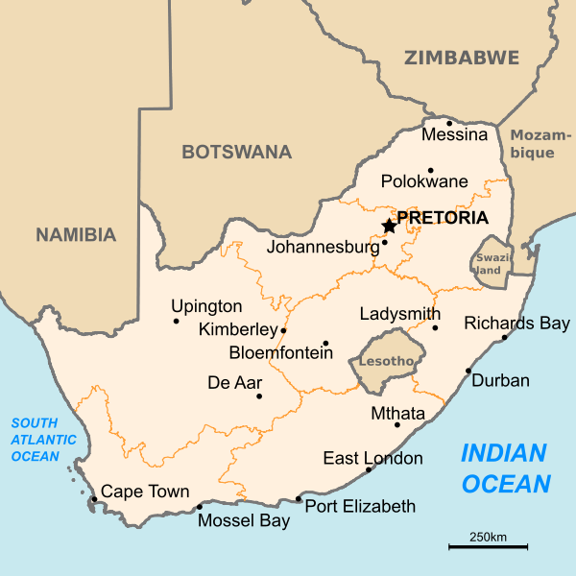
Source: mining.com
Figure 2: Map of East London
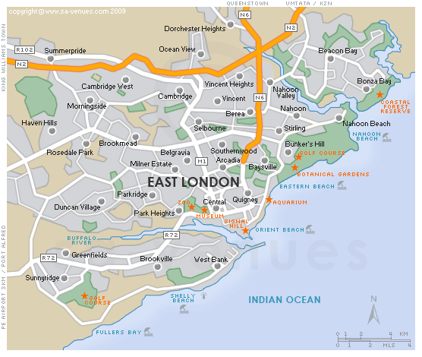
Source: kathyrain.blogspot.co.za

CHAPTER ONE

Overview of the study

INTRODUCTION

According to Carol Dauda (1996), Mdantsane is regarded as the second largest township in South Africa in area size, after Soweto. The history of Mdantsane can be better understood within the broader context of economic and rural transformation that took place in the late fifties. This was the period that witnessed crucial developments that included industrialisation, the growth of urbanisation and the influx of Africans who serviced the towns and manufacturing industries. For the Department of Bantu Administration and Development, these developments created a new problem of control. To address this crisis, new policies were created to control Black people in urban areas, by putting them in urban locations. In these locations, opportunities for personal development through trade were limited; in many cases Blacks were denied property rights, and their access to these locations was strictly monitored. As a result Blacks were forcefully removed from West bank in East London, their area being earmarked for the development of industries. They were also removed from the East bank, because East bank was a multiracial residential area which was becoming too crowded for the East London municipality to endure. Mdantsane’s creation therefore was envisaged as a ‘dormitory township’ that would offer cheap African labour for East London industries; a place that would draw away Black Africans from East London residential areas, but remain part of East London as a source of labour. The advent of the Black commercial middle class in Mdantsane can be traced through the narratives of phase 1 entrepreneurs (1967-1979) who operated viable businesses at that time. According to one of the informants, the advent of the Black Commercial middle class, dawned with the establishment of the homeland system of governance, in the Ciskei and Transkei within the Eastern Cape boundaries (Mr S. Tanana 22/6/2014). The government then, played a significant role in stimulating entrepreneurship through incentives and other capital stimulation initiatives. However, since 1994, there has been a rapid and extensive transformation in township entrepreneurship; which has seen a visible increase in the number of businesses that are run by foreign nationals.

The arrival of these new foreign operators and their domination of this economic sector have created tension between them and the South African operators. This tension has been more pronounced especially with the Somalis who dominate this sector. Thus in the xenophobic attacks of 2008, a considerable number of foreign businesses were looted and burnt down (Charman Andrew,Piper Laurence and Petersen Leif. 2012: 48). The current scenario of hostility between local and foreign business operators has been described by Loren Landau (2010:213) as two demons with which South Africa must contend; first is a perceived enemy within: “an amorphously delimited group of outsiders that is inherently threatening, often indistinguishable from others, and impossible to exclude spatially”. The second demon, Landau claims, rests in a society prepared to kill, to rid itself of those retarding the country’s post – apartheid renaissance.

BACKGROUND

Phase 1 referred to in this study, refers to the Black Commercial middle class that opened and ran businesses in Mdantsane between1967 and 1979. The first government business building in Mdantsane was in NU1, (the first Native Unit) of Mdantsane, and it consisted of three rental premises. .Among the first business people to rent in that building was Mr Gaxela, Mr Gabelana and Mr Mginyana. Other phase 1 members that are part of this study are Mr Dyobiso, Mr Saule, Mr Mpepho, Mr Mvemve, Mr Qhinga and Mr Mpendu. The Black ommercial middle class of phase 1 is composed of three distinctive groups: self-made entrepreneurs that rose from rags to riches and partially helped by the government; those that had some informal business background from Tsolo, who just continued with their informal businesses in Mdantsane, and those who ran formal businesses in Tsolo, and quickly moved out of rental premises in Mdantsane and bought their business sites. The Black Commercial middle class of phase 1 is recognised in Mdantsane for its economic contribution; as a result, streets and bus stops are named after it. The commercial irony is that during this study in 2014, all what used to be their business premises was rented out to foreign nationals as shop or Church premises.
The Black Commercial middle class of phase 2 can be regarded as new entrepreneurs of Mdantsane who built their businesses on the models of phase 1 Black Commercial middle class. They differ from the members of phase 1 because when they started to operate, the business infrastructure was already in place, and they entered into business because of new business opportunities created by the expansion of Mdantsane. This is the Black Commercial middle class that operated their businesses when Mdantsane was under the Ciskei homeland system (1980 – 1994). During this period, Blacks were encouraged into business through incentives such as favourable tax, cheap land and financial support from the government. Ciskei government’s efforts included issuing out loans through Ciskei National Development Cooperation (CNDC), holding workshops and trainings for black business owners. This class is composed of three types of beneficiaries of the homeland system: (1) The bureaucratic beneficiaries who became the Black commercial middle class members through government jobs, (11) Traditional beneficiaries like headmen and chiefs who received recognition and salary from the government, and (111) Black Commercial beneficiaries who received loans through the CNDC, to be able to run supermarkets, hotels, petrol stations and Bottle stores. Phase 2 members that are part of this study are: Mr Nomtshongwana, Mr Guzana, Mr Soxokashe, Mr Kwakweni, Mr Toyana, and Mr Tanana.

Phase 3 (post 1994) deals with the arrival of the foreign nationals in the township economy, and how it directly impacted on the Black commercial middle class. In Mdantsane, foreign business operators came soon after the 1990 political resistance that had crippled Black businesses. Businesses associated with homeland government were burned and looted, thus taking the Black commercial middle class out their businesses, and degrading them to the lower class. Phase 3 members were enticed by the gaps created by the 1990 political upheaval and were prepared to rent empty business premises for their businesses, thus turning formal business premises into informal businesses. That has led into price competition that has resulted into the gradual decrease of local Black commercial middle class operators; locals are either closing or renting out their shops to the foreign business nationals. This situation has become a fertile ground for xenophobic attacks, where local members resist the price competition implemented by foreign nationals, and resort into armed attacks, as was experienced in Cape Town in 2006.

The same killings and voluntary deportations have been experienced in 2015 when xenophobic attacks occurred in Durban. According to the Human Science Research Council report conducted after the 2008 xenophobic attack, the causes identified were relative deprivation, related to competition for jobs, commodities and housing, psychological categorisation processes that are nationalistic, South African exceptionalism, related to the feeling of superiority to other Africans, and exclusive citizenship referring to nationalism that excludes others (HSRC, 2008); a reflection of the connection between xenophobia and genocide on one hand and issues of economic competition on the other.

1.3 RESEARCH PROBLEM

The South African business space is a contested one. The oral history of the Mdantsane business pioneers is often painted rosy, with the old guard that operated the first businesses in the late 1960s indicating that during that time, business boomed, creating a formidable Black commercial middle class. They also indicate that, the inception of the homeland system increased the Black commercial middle class through business opportunities created by the homeland government and the expansion of Mdantsane. However, phase 3 (post 1994) reflects the opposite of phase 1 and phase 2 of the Black commercial middle class. This township business space has taken a dramatic turn; the Black commercial middle class members are out of their businesses, thus relegated to a lower class. Some of their businesses have reached the level of being less competitive, and eventually closed, and rented out to newcomers, especially the Somali nationals. The once thriving Black commercial middle class businesses have begun to wither, as some business premises have become white elephants.

This decline of local Black Commercial middle class has compromised their livelihoods, and led to high unemployment, while on the other side, foreign nationals have rejuvenated the township economy and seem to be faring well and making some money.

RESEARCH QUESTIONS:

Primary Research question
How did the Black commercial middle class evolve in Mdantsane during the period of 1967 to post 1994?
- What was the nature and evolution of Mdantsane entrepreneurship during the period of 1967 to the 1980s?
- What contributed to the rise of the Black Commercial middle class in Mdantsane between 1967 and 1979?
- How did the homeland policies enhance or limit the rise of the Black Commercial middle class in Mdantsane between 1979 and 1990?
- What led to the gradual fall of the Black Commercial middle class in Mdantsane post 1990?
- Which new strategies can facilitate the resuscitation of the Black Commercial middle class in Mdantsane?

1.5 RESEARCH OBJECTIVES:

- To understand the processes and structures that led to the generation of local entrepreneurship in Mdantsane.
- To investigate the internal and external forces that led the rise of the Black Commercial black middle class in Mdantsane.
- To understand how the post 1994 policies contributed to the fall of the Black Commercial middle class in Mdantsane.
- To explore new strategies that can facilitate the resuscitation of the Black Commercial middle class in Mdantsane.

1.6 SIGNIFICANCE OF THE STUDY

There is still a lack of a comprehensive study on the history of internal economic activities and local entrepreneurship in the South African townships. Previous scholars have been focusing on different themes that include resistance, gangs, Jazz and others; a portrayal of townships as sites of resistance and labour reserves. This failure has resulted in a representation of Black people as not taking part in the economic activities, but mainly as workers. The study hopes to explore the history of Mdantsane entrepreneurship, and the contribution made by its pioneers to the local economy. This is very significant to understand, so as to devise appropriate strategies that can facilitate the resuscitation of the Black Commercial middle class in South African townships. The fall of the Black commercial middle class in South African townships has left families with emotional scars that are often seen to be linked to xenophobic attacks. It is therefore imperative to conduct in-depth research in order to get into the root-cause of this fall, and the continuous carnage of Africans killing one another

1.7 DELIMITATION OF THE STUDY

The study was conducted in Mdantsane from NU1 to Nu14. A total of 24 business operators; including those who rented out their business premises, was selected for the study. Most foreign business operators could speak and understand English, although they differed in fluency, and locals expressed themselves in both Xhosa and English languages. According to Dauda (1996), Mdantsane is regarded as the second largest Township in South Africa, after Soweto, in terms of geographical spread, not in terms of population figures; therefore it can be representative of the study of South African townships

1.8 LIMITATIONS OF THE STUDY

The study would have been more representative if the Black Commercial middle class of other townships in the country had been included, but this was impossible due to time constraints and the high costs involved. Most of the Black Commercial middle class members of phase 1 have passed on, and tracing their siblings who could furnish the researcher with the relevant information was too costly in terms of time and material resources, as some have migrated to other places.

Foreign entrepreneurs are hands-on workers, therefore during the interview they would sometimes be requested to attend to business requests, thus the interviews were frequently interrupted and took much longer than the original time allocated.

1.9 CHAPTER OUTLINE

The study is made up of seven chapters:

Chapter One introduces the study by detailing the research problem which centres on the rise and fall of the Black Commercial middle class in three phases of Mdantsane history. The research problem and the objectives of the study are provided. The justification of the study is also provided.

Chapter Two deals with the historical evolution of the Black Commercial middle class in South Africa; it covers Literature review of related studies that have been carried out by other scholars in the past.

Chapter Three outlines the Research Methodology that was adopted to conduct this study. It offers a roadmap on the research design and the research approach that was adopted. This study used a case study of Mdantsane using a qualitative approach; therefore this chapter explains the sampling techniques used and addresses ethical issues encountered

Chapter Four focuses on the Black Commercial middle class of phase 1 in Mdantsane: pioneer entrepreneurs who owned and ran businesses in Mdantsane between 1967 and 1979, and also continued during the homeland system. Most of their businesses grew from rental sites and developed to new business sites bought and developed by the owners.

Chapter Five looks at the Black Commercial middle class of phase 2 who operated under the homeland system (1980 – 1994), building on the models of the Black Commercial middle class of phase 1. This was the period when the homeland government was supporting Black business people by providing them with tax incentives, business workshops, business trainings, and financial support through Ciskei National Development Corporation.

Chapter Six provides a narrative of phase 3 Mdantsane entrepreneurs that included foreign nationals (Post - 1994). The chapter looks at how the arrivals of newcomers post 1994 impacted on the businesses of phase 1 and phase 2 Black commercial middle classes in Mdantsane.

Chapter Seven provides a summary of the study. Furthermore, the chapter provides concluding statements and recommendations based on the information provided by the participants.

CHAPTER TWO

THE HISTORICAL EVOLUTION OF THE BLACK COMMERCIAL MIDDLE CLASS IN SOUTH AFRICA

2.1 INTRODUCTION

This chapter explores debates within the literature that focus on the evolution of the Black Commercial middle class. Research on the middle class is often motivated by an interest in the political, economic and social benefits associated with the term. In order to understand the rise of the Black Commercial middle class, it is important to look at its evolution from under the Union of South Africa, the National Party government, and under South Africa’s emerging democracy. According to Ronelle Burger, Steenkamp Cindy van der Berg Servaas and Zoch Asmus (2014:3), previous attempts to understand what Black Commercial middle class means, have been frustrated by disputes around the origins and meaning of class.

Historically South Africa’s social landscape has reflected the promotion of white empowerment at the expense of other population groups. Blacks have been restrained from acquiring labour market skills, and under the National Party rule the whole education system entrenched limitations to the growth of the Black Commercial middle class. This permanently elevated the white population above the rest of other groups in the social structure. According to Carlos Garcia Rivero,du Toit Pierre and Kotze Hennie (2003: 22), the explanation of the evolution of South African politics and the South African labour market by authors such as Chisholm 1984, Davis 1979, Proctor-Sims 1981 and Human 1993, facilitates understanding the extreme distance between the White middle class and the Black middle class. This distance made the South African society to be characterised by a lack of social cohesion and economic injustice, since race persisted to be used as a marker and a sorting mechanism in many dimensions of daily life, including geographical space, educational opportunities, the labour market, social networks and political party affiliation.

However, the recent analysis suggest that the liberation of the political process since 1990 has resulted in the appointment of Blacks, Coloureds and Indians in positions historically reserved for the white population. This has increased the Black share of the middle class dramatically, indicating that gradually race may no longer be the sole marker and a sorting mechanism on South Africa’s social landscape. This has brought positive expectations among the Black Commercial middle class because as far as they are concerned, a growing and more racially representative middle class can help shape a more just, dynamic and integrated society. According to (Muller 1995), as quoted by Carlos Garcia Rivero et al (2003: 7), the size of the middle class is indicative of the existing level of inequality in a society, as a result , a wide middle class is indicative of low levels of in equality.

However, according to Schlemmer and Levitz (1998:1), as alluded to by Carlos Reviro et al, in South Africa the growth of Black middle class has been paralleled by the increase in unemployment that mainly affected unskilled black section of the population. They contend that:

‘Among South Africa’s grave socio-economic problems, unemployment
is one of the most serious and intractable. It is the most important
cause of poverty, it has replaced race as the major factor in inequality
and it underlies or contributes to a wider range of other socio-economic
problems’(1998:1)

According to Carlos Rivero et al (2003:24),the growth of Black middle class, and the increase in unemployment has bisected the Black population, and created two groups, one being located at the highest level of the middle class and the other still at the lowest level – lowly skilled and unemployed

2.2 DEFINITION OF THE MIDDLE CLASS

Karl Marx and Max Weber are regarded as pioneers of the analysis of class. Marx defines class as shared structural positions within the social organisation of production; to him class originates from shared interests and economic position. To him a certain class only exists in conflict with another. He distinguishes two main social classes; bourgeoisie (upper class) and proletariat (lower class). He regards the bourgeoisie as the owners and the controllers of means of production (physical capital) while the proletariat does not, and therefore needs to sell their labour to the bourgeoisie. Marx defines the middle class as a third class of petty bourgeoisie, such as small business owners, shop-keepers, artisans and managers who are similar to bourgeoisie because they are able to control (but not necessarily own) the means of production, but differ from the upper class because they work alongside their staff. To Marx, this group would eventually be absorbed into the upper class.
In contrast, Max Weber sees class as shared life chances such as opportunities for generating income in the market. Like Marx, Weber also differentiates between those with access to property and land, and those without. To him those without, have to earn their living through work, therefore their education, skills and knowledge determine their market value, their occupation and their wages, and in turn their wages determine the life style that an individual can afford. According to Jeremy Seekings (2009), as quoted by Ronelle Burger, et al, Weber believes that ownership of the means of production is not the only determinant of differences in social status, but it can also emerge due to other factors such as skills or credentials.
Central to both class definitions, is education, social status, income, wealth and shared life perspectives. Carlos Rivero et al (2003: 10) therefore conclude that the middle class as a social group mainly integrate professionals, business people and clerks, both in the public and private sector and civil service – new middle class- plus those individuals running their own businesses with similar income – old middle class. This is in similar to Roger Southall’s version who claims that, African middle class was defined by its education, literacy and employment. (Southall 2014)

According to Justine Visagie (2011:4), a middle class may be defined by ‘affluence’ (households with income per capita of R1, 400 to R10, 000 per month) and by the ‘middle income strata’ (households between 50% to 150% of the median per capita household income). In the ‘middle class affluent’, the upper bound of R10, 000 separates the upper class from the middle class, while the lower bound of R1, 400 separates the middle class from the lower class.
Grace Khunou (2012:1) argues that being middle class and black in South Africa is heterogeneously experienced and thus complex, because the middle classness for blacks during the apartheid was constantly shifting due to its socio-economic and political impermanence. Middle class membership included continuous negotiation driven by inclusiveness in one’s own community and the effects of being racially othered in interaction with whites and white spaces. To her, class categorisation should not only be informed by academic pursuits but by the lived experiences of those categorised.
Ronelle Burger et al (2014:8) define the middle class as non-poor households who have a low probability of falling into poverty but who are still below an affluence threshold.

2.3 THE ORIGIN OF BLACK MIDDLE CLASS IN SOUTH AFRICA

There is no agreement among scholars about the origin of the interest in the subject of class as deduced from Alan Cobley and Jeremy Seekings. According to Alan Cobley (1990: 3), as quoted by Roger Southall (2014: 1), an interest in the subject of class in South Africa developed in the 1970, by the radical historians who were concerned about the origin and development of a black working class, whom they saw as potential drivers of the revolution.
Contrary to Alan Cobley’s version, Jeremy Seekings (2009), as quoted by Roger Southall (2014:1), believes that class was long a central concern of liberal scholars from the 1940s, but it was treated as a subordinated appendage of the black proletariat. Southall attributes this to the struggle history which often reflected the lot of middle class to have been unheroic. He also blames the failure to trace the holistic evolution of the black middle class, to the multi-faceted nature of the struggle against apartheid. To him the class structure settled by settler capitalism left little room for an African middle class to grow. It was only the shortage of white labour of the 1970s that led to increase in provision of black education and housing.
African middle class origin can be traced in the educational efforts of the Christian missionaries of a variety of nationals and denominations which were established from the early days of white settlement in South Africa. According to Cobley (1990:59), as quoted by Roger Southall (2014:3), ‘the missionary endeavour was crucial to the future character of the black petty bourgeoisie.’ The saving of souls demanded the promotion of literacy and the teaching of the English language so that earthly sinners could read the word of God and with that came the missionaries’ commitment to spreading civilisation. Education was an important asset required by the colonial cash economy; missionary societies therefore established several ‘Native Training Institutions’ in the Eastern Cape, Natal and Lesotho. This ‘Native education’ created tension among South Africans; whites were suspicious of educated Africans, and wanted them to be limited to industrial subjects, whilst within African communities, educated Africans received material rewards and social respect. In the townships and cities, industrialisation and urbanisation increased the scope for Africans in trade and business to service the needs of growing township communities and few entrepreneurs were able to sustain a position among local elites. The African elite received letters of exemption from the provision of ‘native laws’, thus increasing their legality to conduct business and acquire land outside locations. Professional associations, business organisations and common social activities, reinforced a sense of elite identity. Although privileged, this elite group was blocked by racial barriers to assume upward mobility (Southall, R, 2014: 3 – 7).

2.4 BLACK MIDDLE CLASS AND POLITICS

2.4.1 ECONOMIC INDUSTRY

According to Blade Nzimande, the post-World War 2 period was marked by the transition to monopoly capitalism, massive state intervention in the economy and the smashing of black popular and trade union organizations. The subjugation of the black masses by the state created favourable conditions for the unprecedented economic boom and industrial peace of the 1960s (Nzimande, B,1986:41). During the post-war period, Capital increasingly required ‘trainable’ African workers, and that resulted into the formation of the National Institute of Personnel Research (NIPR) in 1946, and its pre-occupation with finding ways and means of improving selection techniques for black workers, while improving productivity.
With the development of a large –scale manufacturing, made possible by a massive domestic steel-and-electricity industrial revolution from the 1930s, many Africans had been attracted to the new urban job markets. Manufacturing, furthermore, permitted a relatively permanent and residentially stable African labour force, involving not only the workers but also their families. (Eidelberg Philip, 2015:2)
According to Baskin (1991:17), as quoted by Michael Neocosmos (1994), South Africa’s Gross National Product grew at 6 percent per annum, and South Africa was at the time the country with the highest growth rate in the world. Among the important results of this growth, was the increase in the number of Africans working in manufacturing, denoting an increase in the number of skilled African workers. As a result the South African economy became more dependent on consumption by blacks for its internal market. Another result was an increase in black South Africans entering the education system to provide for the increased industrialisation.
However, by 1982, South Africa was feeling the effects of the world economic crisis, the price of gold fell, a balance of payments deficit created by the importation of capital equipment for the mini-import substitution industrialisation process, led to an ‘unprecedented level of indebtedness’(Lodge et al), as quoted by Michael Neocosmos. As a result of IMF loan conditionalities, the government scrapped whatever subsidies that were in place to consumers and increased sales tax, which shifted the fiscal burden to the poor. All this led to a steep increase in the unemployment rate. By 1985, African unemployment represented about 25 percent of the economically active population. In South Africa this economic crisis was accompanied by a prolonged drought that resulted in an increase in the food price as well as the level of rural-urban migration. From 1981, township residents were subjected to rent hikes which increased in frequency after municipal elections in 1983. To manage the growing discontent, the state introduced three legislations: the Black Local Authorities Act, the Industrial Relations Act and the tricameral parliament; collectively known as Koornhof Bills. These structural changes formed background to the mass resistance of the second half of the 1980s.

2.4.2 APARTHEID

According to Southall, the class structure fashioned by the settler capitalist left little room for an African middleclass. Indeed, during the long course of history it was designed to inhibit its growth, except in so far as the white minority regime required a class of subaltern allies, as a result the characteristic of the African middle class was its small size and its limited upward movement ( Southall, R. 2014:2).
Under Apartheid, black South Africans were denied business opportunities, dispossessed of property, forcibly relocated and barred from occupational advancement (Visagie, J.2011: 2). The racial discrimination in South Africa has produced a situation where members of the African middle class share many of the humiliating conditions with the working class. They have been together victims of forced removals and influx control, and their class differences on the social and political terrains have been blurred (Nzimande, B 1986:49). These blurred class differences are expressed by Mr Shuenyane, as quoted by Nzimande:

There is no such a thing as the ‘black middle class’
we are all blacks. Legally, we suffer from the same
restrictions: economically, we are standing on the
pavements watching the main stream go by: socially,
even the ‘cocktail set’ still go back to the ghettoes.
so why is there this cry that we are selling out. It is a cry from
the frustrated hearts of mediocrity, from the forces of low-
standards and of non-achievement – the forces of laziness (Nzimande, B. 1986:49)

However, the middle class, by virtue that it was the ‘upper’ on the occupational strata of African society, they were considered better off than the mass of Africans. The South African government also contributed to the creation of black middle class through various political reforms implemented in the late 1980s; the tricameral constitution of 1984, granted representation to Indians and Coloureds in the central policy, but continued to exclude Africans. The Black Local Authorities Act granted full municipal status to elected Black Authorities. This was government strategy to secure support from the African middle class against the threat of ‘Marxist tyranny’ (Southall, R (2014:17). According to Detlev Krige, by the middle of the 1980s the apartheid state was actively promoting the development of an urban black middle class in order to keep black elites from becoming radicalised (Krige, D. 2012: 39).

Thomas E. Nyquist sees the urban middle class as a multi-bonded group, which by the nature of its bonds experiences the kind of cohesion that suggests it has at least a partial independent identity within society. The extent of its multi-bondedness is driven by common family background and family life, common achievements that distinguish them from the rest of the community, common bonds of association, a binding network of social relationships, and common attitudes that tend to distinguish the middle class from the remainder of the community. ( Nyquist, E.T. 1983: 132)

2.4.3 HOMELAND SYSTEM

Bantustans were created through the white South African state’s policies of separate development, to stem the tide of urbanising Africans, by becoming economically self-sufficient territories. The Tomlinson Commission which was set up in 1949 to explore this rehabilitation of the Native areas published its report in 1954, and recommended that these territories should be made economically viable by building African businessmen through a Bantu Development Corporation. The Bantu Investment Corporation (BIC) that was set up in 1959 was mandated to develop a capitalist black class and initiate investments in these territories. White owned businesses were bought by the BIC, and transferred to local business people. According to Krige, both the business elite and the government of the time praised and welcomed this entrepreneurial group of elites, as they saw this class as an important factor in making homeland strategy work, as such urban entrepreneurs were expected to transfer their capital, experience and skills to the ‘newly independent homelands’ (Krige, D. 2012: 30). In 1965 a regional specific body, the Xhosa Development Corporation (XDC) was formed for both Transkei and Ciskei, thus Africanising the economy, and creating a black middle class. The composition of the XDC leadership was all White, nominated by the Minister of Bantu Administration and Development, and all its Managing Directors appointed in consultation with the Minister. On the meeting of granting of independence to the Transkei, BJ Voster stressed the importance of replacing white officials with black officials, so that it could not be claimed that the South African government was continuing to administer the Transkei through its white officials. In 1976 the XDC was split into the Transkei Development Corporation (TDC) and the Ciskei National Development Corporation (CNDC) to display the legitimacy of the Transkei independence. According to Jeff Peires, Matanzima’s removal of white expatriates from leadership positions in the Transkei, gave the Transkei bureaucrats and officials a sense of intellectual coherence and credibility. The geographical isolation of Transkei, its rural character, its economic backwardness, and the greed and prosperity of its educated elite, all combined to create a climate where Transkei independence seemed a great deal more than a bad joke (Peires, J.B. 1992:367). This Black Commercial middle class created by the homeland system has been given different labels. Roger Southall as quoted by Jeff Peires, has dubbed them the ‘beneficiaries of independence; Innes and O’Meara speak of ‘elements of the pretty bourgeoisie which seek to transform themselves into a bourgeoisie through collaboration with the Apartheid state’ (Peires, J.B. 1992: 382). According to Jozana, as quoted by Jeff Peires:
The Bantustan leaders, often seen as puppets by the liberation forces
have secured support – bases from various social groups that have emerged
within white-created institutions. These groups have something to show for
their gains: wealth, position, status and authority. To them it is
inconsequential that the status they enjoy is confined to their own circles.
they will resist all attempts by the liberation movements to change the status
quo. (Peires, J.B. 1992:383).

2.5. POST – APARTHEID BLACK MIDDLE CLASS

According to Krige, Africans living in urban areas before the onset of constitutional democracy were a homogenous group lacking in significant forms of social differentiation. The continued side-lining of long histories of social differentiation among urban Africans today has the effect of not only of indirectly overstating the role recent policies such as affirmative action has played in the emergence of the ‘new’ black middle class, but also in limiting the public understanding of the historically constructed, multiple and complex meanings that practices of consumption have had in urban African municipal locations. (Krige, D.2012: 19)
The rise of the black elite and the black middle class has drastically altered the social structure of South African society and economy, and the way in which class is being talked about. It has been the educated and the skilled that have benefitted from the opening up of new employment opportunities in the services sectors of the labour market, boosted by the end to employment discrimination and the implementation of national labour and procurement policies such as Affirmative Action and Black Economic Empowerment. As a result of this, there has been a marked increase in income inequality between the new black middle class and the underclass. All over urban South Africa, it is reported that middle class residents of former urban African townships have left these townships and settled in former white suburbs, thus there is no new Black Commercial middle class in the South African townships. Black wealth amidst growing inequality in former townships , as evidenced in expensive cars they drive, is seen as a form of conspicuous consumption, a symbol and interpretation of the underlying values of materialism that animate the new black classes, and a turning away from a mutualist philosophy of Ubuntu (Krige, D. 2012:27)
This increase is also echoed by Leslie Bank in his Daily Dispatch article (Black middle class rising) where he compares Buffalo City middle class figures of 2001, with those reflected by the 2011 Census. He argued that there the BCM’s middle class has changed colour, ‘In 2001 about half the middle class was white, but in 2011 Whites make up only about 20% of the middle class’. (Dispatch, February 22, 2013). He further argued that the lower middle class of whites has disappeared, leaving whites either richer or poorer than they were before. It is this space he says has been taken by blacks to enter the middle class. To Bank, BCM’s middle class is a ‘surrogate class’ which is tied to the state sector; it is dependent on state resources for its salaries and tenders, and is shackled to the ruling party. He argues further to say BCM middle class is politically compromised to have the luxury of independent political alignment, and to it leaving the ANC would be a class suicide.
The limited changes in the class structure in the South African society, is discussed by Jeremmy Seekings who compares 1993 (eve of the first democratic elections) class distribution with the 2008 (fifteen years later) one. According to him, in 1993, the upper classes accounted for 12 percent of the total population of households but 45 percent of the national income. The middle class accounted for 48 percent of households and 45 percent of national income. The lower classes accounted for 41 percent of households, but only 10 percent of national income. This he compares with the 2008 class structure as shown by the figure below:

Figure 3: The Class Structure of South Africa 2008 (calculated from National Income Dynamics Study data)
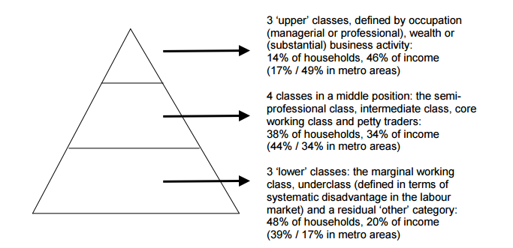
Source: Seekings J (2010, pg. 7)

The comparison suggests that the upper classes have maintained their privileged position, and perhaps even grown slightly. The middle class category has, however, shrunk in terms of its share of the total population of households, and the lower category has grown in terms of its shares of both the total population of households and the national income. This growth of the lower class is attributed to the government’s social assistance programmes (Seekings, J. 2010:7). As far as Seekings is concerned, the class structure has changed but has not resulted in any major change in inequality; the lower class has remained entirely African. He attributes the acceleration of some African people into upper classes to educational opportunities and to the government policies that promoted affirmative action and ‘black economic empowerment’ (Seekings, J. 2010: 8). According to Rivero Garcia et al, the new class structure is bisecting the black population and creating two groups, one being located at the highest level of the middle class and the other still at the lowest level of lowly skilled and unemployed.
Dorothy Atkinson paints a bleak scenario of the South African economy, claiming it’s coming to the end of its post – apartheid honeymoon phase. She argues that the economy is not productive; it is based on government services and retail, and almost all households are highly indebted. She also cites patterns of bureaucratic bloat, corruption and irregular dealings. To her, South Africa has been surviving on the tax revenue of the mining and manufacturing sectors which are currently on decline, as a result there are many signs that South African economy is faltering, and the fiscus is under severe strain (Atkinson, D. 2014: 50)

2.6 POST – APARTHEID POLICIES, MECHANISMS, AND INSTRUMENTS TO TRANSFORM AND DEVELOP THE SOUTH AFRICAN ECONOMY

2.6.1 THE GROWTH EMPLOYMENT AND REDISTRIBUTION (GEAR)

In an attempt to “reshape the socio-economic character of the country” (DBSA Report, 2005), the South African government put in place certain policies and institutions to create an environment conducive for the development of the Small, Medium and Micro Enterprises sector which generally forms a second economy together with other areas of economic activity. One of these policies is the Growth Employment and Redistribution, a macro- economic policy adopted by the South African government in June 1996 with the aim of increasing economic growth. There are many views that have been advanced with regard to the extent to which the Growth, Employment And Redistribution policy has been relevant or effective in addressing the needs of the second economy. In South Africa these discussions have tended to take place within the context of the ‘two-economy’ debate; an underlying assumption that the “first economy has intrinsic qualities that conspire to keep people in poverty” (DBSA Report, 2005). According to Edward Webster (2004), the ‘two economies’ analogy is misleading because the activities of the informal sector in the periphery are dependent on the formal economy to such an extent that it is highly unlikely for ‘peripheral activities to expand independently’ and stimulate growth in the formal economy. These activities can only expand “to the extent that the formal sector itself expands” (Webster, 2004:19).

In these discussions there are some who feel that the government has not done much to address the prevailing economic and developmental challenges. Others acknowledge that the anticipated growth rates have not been realised, and they argue that this is just a temporary setback which is in itself, a result of factors such as lack of foreign investment and low capital growth. The Development Bank of South Africa Report (2005) argues that government policies have so far been more relevant to the needs of the “first world globally integrated economy”. When the government introduced the GEAR programme, the objective was to maximise economic growth with the hope that the benefits accruing from this growth would ‘trickle down’ to the second economy. It was anticipated that the SMMEs would identify and seize the productive opportunities created via economic growth; this would have allowed them to develop and consolidate their activities, thereby contributing positively to the economy through job creation and poverty alleviation.
The GEAR macro-economic policy is criticised of its central aspects that are viewed to be largely neo-liberal. Although GEAR is a home–grown policy, it shares the same characteristics with the Washington Consensus. Some of the key features of GEAR are that the government should make efforts to facilitate the integration of the country’s economy into the global economy through the removal of foreign exchange controls, and also that privatisation should be accelerated (Padayachee Vishnu & Fine Ben, 2001). The ultimate aim of all these measures is to achieve a high rate of economic growth and consequently more jobs that are essential to the reduction of poverty are created (Padayachee & Fine, 2001). But seemingly the necessary rate of economic growth and jobs that were expected upon adopting the GEAR within its first four years were not attained; inequality has persisted in South Africa, and that indicates that the poor continue to get a little share of the national cake. The continued existence of income disparities between the rich and the poor is a negative sign which reflects badly on the effectiveness of any macro- economic policy. The South African government has also introduced an implementation strategy meant to strengthen economic management, known as, the Accelerated and Shared Growth Initiative (ASGISA).

2.6.2 THE ACCELERATED AND SHARED GROWTH INITIATIVE (ASGISA)

The introduction of Accelerated and Shared Growth Initiative for South Africa (ASGISA) in South Africa’s policy terrain has been met with different views amongst different stakeholders. The Congress of South African Trade Unions’ (COSATU) main concern is for government not to lose sight of the fundamental point that “increasing equity and accelerating growth are complementary not competing goals” (COSATU, 2005). This concern seems to emanate from the observation that previously, when the government pursued its growth -orientated economic initiatives as encapsulated by the GEAR policy, workers’ needs have not been adequately met, instead “ the bulk of the benefits from growth have been captured by business” (COSATU, 2005:9).

The ASGISA implementation plan also seems to have failed to shake off the neo-liberal tag associated with macro-economic policies such as GEAR because it still talks about trickle-down economics. Such an economic policy attributes the success of the informal economy to the success of big business. There are also misgivings on the lack of clarity in ASGISA on how the cost of doing business can be reduced.

2.6.3 NATIONAL SMALL BUSINESS DEVELOPMENT ACT OF 1996

The National Small Business Development Act of 1996, created six institutional pillars to facilitate the transformation and the development of South African economy through Small Medium and Micro enterprise (SMME): The Ntsika Enterprise Promotion Agency to provide non-financial or business development services; the Khula Enterprise Finance to support retail finance intermediaries, dealing with the SMME entrepreneurs; the Local Services Centres for small business support; the Tender Advice Centres to provide advice concerning public procurement contracts; the Manufacturing Advice Centres to improve competitiveness in local, national and international markets; and the Community Public Private Partnership Programme established in 1999 to facilitate the entrepreneurial base in rural and peri-urban South Africa. Other interventions included the Department of Trade and Industry’s Small and Medium Sized Enterprise Development Programme, and its Black Business Supplier Development programme, to provide specific incentives to promote BEE in small and medium-sized enterprises. The DTI’s enterprise Industry and Development Division is responsible for fast-tracking the implementation of BEE strategy. The government‘s Strategy for Broad- Based Black Economic Empowerment stressed the importance of new black owned and controlled SMMEs for the development and promotion of small business generally. The Green Paper of 1997 on public sector procurement established a framework that was to make the tendering process more available to black people and to smaller enterprises. Lastly was the creation of the National Empowerment Fund that looked at the promotion and support of business ventures pioneered and run by previously disadvantaged persons.

With so many institutional pillars to support transformation and development through SMME, the question is why there is no development in the economy. Various reasons for the government’s underperformance have been identified as: the lack of information and this makes it difficult to develop relevant policies and efficient policies in this sector; poor communication- lack of awareness and knowledge of DTI support programmes. Also, accessing finance appears to be the most serious issue, and there is a deep concern that money is not reaching as many potential entrepreneurs as would be liked (Financial Mail, 14 May 2014).

2.7 CONCLUSION

There is no mutual agreement on the role the state should play in the market, and the current policies seem to have promoted a black “elite” rather than broad – based black economic empowerment. The ruling ANC still attributes the racial inequality to Apartheid, thus it is using state and parastatal institutions to promote black and female advancement. On the other hand, the official opposition feels the ANC is reracialising South Africa. The criticism of BEE strategies has been voiced by both Archbishop Desmond Tutu and COSATU, claiming that ‘these strategies favour small elite that is closely connected to the government’. (Rogerson Christian, 2004:124)

CHAPTER THREE

RESEARCH METHODOLOGY

3.1 INTRODUCTION

This chapter deals with the procedures that the researcher has followed in this dissertation. This does not only consist of an outline of the specific research techniques, but it also addresses the philosophical, methodological and ethical commitments which are associated with the methods used in this study. The main data gathering instrument used is in-depth, semi-structured interviews. Other methods used included Focus Group Discussions (FGDs) and Observation.

First, the assumptions behind these research techniques are discussed before examining their relevance to the study. It is therefore relevant to highlight the extent to which the qualitative approach employed is vital for the study, both at the level of techniques and the level of methodology. The chapter tries to show that different data gathering instruments used are best suited for the research, and support the different philosophical assumptions that underlie them.

3.2 RESEARCH DESIGN

In this study, the Black Commercial middle class is divided into three phases. Phase 1 is defined as the first group of people to open and run businesses in Mdantsane (1967 – 1979); phase 2 are those people who operated businesses during the homeland system, and phase 3 are contemporary, post 1994, and include the remnants of phase 1 and phase 2 who run businesses or rent their buildings to foreign nationals. Foreign nationals open up their businesses at the same premises that the (locals) have decided to abandon, due to unprofitability of the business.
The researcher conducted in-depth interviews with members of each phase sample, and got a sense from Mdantsane consumers about the businesses run by foreign nationals. For phase 1, interviews focused on their profile (accumulation of business capital, level of education, business background, business operations, and initial successes and challenges that led to decline of business). For phase 2, interviews included questions related to changes brought about by the homeland system on their businesses, business subsidies, the tax system, business competition and government regulations, and the beginning of business degeneration. For phase 3 the interviews focused on their background, survival strategies in business, business contracts with landlords, business operations and the business challenges.

3.2.1 CASE STUDY

The study took place in Mdantsane, a South African township between East London and King Williamstown in the Eastern Cape province of South Africa. Mdantsane was established to house black labour for the industries in neighbouring East London. In the 1980s Mdantsane was included in the apartheid government’s Regional Investment Decentralisation Programme (RIDP). The dominant language of its inhabitants is isiXhosa. The researcher has realised that the Black Commercial middle class is replaced by foreign entrepreneurs. Although this is typical to all townships in South Africa, Mdantsane presents a peculiar scenario; it is regarded as the second largest in South Africa, after Soweto, it is mainly populated by one language speaking people; all the current businesses, run by foreigners, are run on buildings that used to be business premises of the Black commercial middle class of Mdantsane. Mdantsane presents an image of both the rise and fall of the Black Commercial middle class. Thus from the perspective of the research topic, Mdantsane was an appropriate choice.

3.3 RESEARCH APPROACH

It is a well-known reality in the research arena that no research is viable unless there is data to support it, and data itself cannot be considered to be legitimate unless the method used to collect it is scientifically valid. Although it is obvious that subjective human feelings and emotions are indeed difficult and even impossible to quantify, qualitative methods are very useful for this kind of study because they aim at capturing the “lived experiences of social world and the meanings people give to these experiences from their own perspectives” (Corti Louise & Thompson Paul, 2004:327). In the light of the above, the qualitative methods have been applied in this study.

3.3.1 QUALITATIVE RESEARCH METHODOLOGY

The term qualitative research is particularly difficult to define because it is an “overarching category” used to describe a range of “frameworks of inquiry, namely ethnography, phenomenology, action research, symbolic interactionism, and grounded theory…” (Schurink Willem, 2005:32). Whilst the term qualitative research can refer to many different ways of conducting research, some authors have preferred useful operational definitions of the term. Denzin Norman & Lincoln Yvonna (2000:3) provide a precise definition of qualitative research. According to them, qualitative research refers to: “a situated activity that locates the observer in the world. It consists of a set of interpretive, material practices that make the world visible.”

These practices turn the world into a series of representations including field notes, interviews, conversations, photographs, recordings and memos to the self. At this level, qualitative research involves an interpretive, naturalistic approach to the world. This means that qualitative researchers study things in their natural settings, attempting to make sense of, or interpret phenomena in terms of the meanings people bring to them. The above definition addresses the main methodological commitments of the qualitative approach which are essentially the defining characteristics of the research approach. In qualitative research the emphasis is on such aspects as the insider’s perspective and naturally occurring behaviour in natural settings.

According to Creswell (2003:181), as quoted by Babbie Earl & Mouton Johann, qualitative research takes place in the “natural setting.” This enables the researcher to develop a level of detail about the individual or place and to be highly involved in actual experiences of the participants. It follows that “qualitative research is best suited for studying attitudes and behaviours best understood within their natural setting, as opposed to the somewhat artificial settings of experiments and surveys”. It is for this reason that this method is also known as “naturalistic inquiry” and “field research.”

This study of participants’ behaviour and actions in a natural setting allows the qualitative researcher to capture the “normal course of events” and indeed to “observe events and actions as they happen” (Babbie & Mouton, 2003:271). The idea is to minimise “intervention” and “interference” as much as possible, which is the opposite of what happens in experimental designs and survey research where the researcher intervenes in the research process, resulting in an artificial set up One important methodological criterion in qualitative research is the prioritization of the “insiders” perspective (Babbie & Mouton, 2003). According to Plummer Kenneth (2001), qualitative research is especially interested in how ordinary people observe and describe their lives or the “emic perspective”. It is thus fundamental for researchers not to over emphasise “grand narratives” at the expense of the participant’s perspective.

Qualitative research is normally conducted in a relatively unstructured and flexible manner; this is mainly to allow for unanticipated events. When planning and conducting qualitative research, qualitative researchers do not follow a rigid research design, instead research plans can be altered midstream to allow for “serendipitous occurrences” (Bryman Alan, 1984:78). A qualitative researcher needs to be flexible throughout the research process and these calls for a malleable design. Thus instead of following “a linear research path” as is the case in quantitative research, qualitative research design tends to be “non-linear and cyclical” (Neuman Lawrence, 1997:331).

Qualitative research is interpretative; the researcher makes an interpretation of the data by developing a description of an individual or setting, analysing data for themes or categories. The qualitative researcher systematically reflects on their own positionality as part of the inquiry, and is sensitive to his or her personal biography and how it shapes the study. This also involves some introspection and acknowledgement of biases, values, interests (or reflexivity) where the personal-self becomes inseparable from the researcher-self (Plummer, 2001)

3.3.2 QUALITATIVE METHODS IN THE STUDY OF THE BLACK COMMERCIAL MIDDLE CLASS

Since the study of the commercial sector involves the understanding of both processes and consequences, qualitative data collection methods play an important role in impact evaluation, by providing information that is useful for understanding the processes behind observed results and assessing changes in people’s perceptions of their well – being. To adequately address the research problem and provide well rounded answers, this study has used qualitative techniques. It was necessary to employ in-depth semi-structured interviews, as well as Focus Group Discussions (FGDs), both of which are qualitative methods of gathering data. The problem under study has dictated the use of qualitative techniques, as argued by Trow (in Bryman, 1984), that “the problem under investigation properly dictates the method of investigation”. The use of qualitative methods is also recommended by Kvale Steiner who argues that “Qualitative methods, like quantitative ones, are tools, and their utility depends on their power to bear on research questions asked” (Kvale, 1996:69).

3.4 RESEARCH METHODS

3.4.1 UNSTRUCTURED INTERVIEWS

In this study the researcher has chosen to use unstructured interviews as a main data gathering instrument. The researcher has chosen in-depth semi-structured interviews precisely because he was interested in the personal life experiences of the respondents. The interview technique in social research is inspired by ordinary everyday conversations, with the only difference being that “an interview is a conversation that has a structure and a purpose,” which clearly distinguishes it from “the spontaneous exchange of views as in everyday conversation” (Kvale, 1996:6). Thus, the use of interviews also provided the researcher with the opportunity to access the subjective experiences of his respondents through their narratives. According to Neuman (1977), “the field interview is a joint production of a researcher and a member”. Interviewees have been seen as “active participants whose insights, feelings and cooperation were essential parts of discussion process that reveals subjective meanings” (Neuman, 1997:371)

The short-comings of in-depth semi-structured interviews are that they do not constitute a proper “scientific method” because of their reliance on ‘interpersonal interaction’. With the use of qualitative interviews, it is therefore difficult to eliminate the human factor in research. The study deals with the Black Commercial middle class that may have been both financially and emotionally affected by their fall; they may try to defend their failures or exaggerate their successes. It is for this reason that qualitative interviews are widely seen as ‘unscientific’, ‘lacking objectivity’ and ‘biased’ (Kvale, 1996:62). Interviews can be expensive and time consuming especially when the respondents are spread over a wide geographical area (Kumar, 1999: 115). The researcher may add his or her bias in framing the questions and during the interpretation of data.

3.4.2 OBSERVATION

Non-participant observation is a research technique used by social scientists and researchers to record activities and events as they unfold in the daily life of a given community (Bless Claire, Higson-Smith Craig and Kagee Ashraf, 2006). Information is collected by observing the social behaviour of people interacting in a social setting. During the research, observing (and sometimes listening to) customers, or the drivers of delivery vans supplying products, has been an important method used to record additional data through observation. Observations are usually made from the perspective of an “outsider” or “stranger,” and the technique involves little or no conversation. A major challenge of this method is to confirm at a later stage what was seen or heard, but it was useful, as there were many instances where confirmation was possible through mere observation. Information collected during in-depth interviews around popular products among the customers could be confirmed by just sitting in the car and observing the flow of customers at each business. Observation is a non-reactive method where subjects of study are unaware that they are under observation. Hence observation is independent of the subject’s ability as well as his willingness to answer questions (Deutsch Morton and Cook Stuart, 1951). This can lead to valuable information without any energy being wasted and without the studied subjects’ reservation. This technique was applied during the data collection in Mdantsane (observing customers, and the interaction between the customers and business operators) because of the valuable data it provided in the field.

3.4.3 FOCUS GROUP DISCUSSION

The use of FGDs in this study has been necessitated by the desire to gain some insight about customers’ opinions about businesses operated by foreign nationals in their areas. In the process, customers were interviewed and group sessions were conducted with three groups at NU1, NU3 and NU5. Since it is not easy to bring different people with different schedules at the same place and same time, participants were lured with incentives such as buying lunch-packs for them and transporting them back home after the interviews, so as to ensure “informed consent” for ethical reasons, as demanded by the six principles of Economic and Science Research Council.

FGDs proved to be useful in allowing for a robust exchange of views amongst the participants on issues that affect them directly or indirectly. Putcha Claudia & Potter Jonathan (2004:47) argue that “a focus group is a situation of freedom.” During the discussions, participants tended to agree on many issues which affect them as customers of businesses operated by foreign nationals. Focus groups allow respondents to react to and build upon the responses of other group members. This “synergistic” effect of the group setting may result in the production of data that might not have been uncovered in individual interviews (Stewart David & Shamdasani Prem, 1990:16).

3.5 SAMPLING

Sampling in qualitative research is usually purposeful; it involves selecting a convenience sample from a population with a specific set of characteristics for the research study. The target population were the Black Commercial middle class in Mdantsane between 1966 and post 1994. The main aim was to encourage 10 participants in each category of phases (1, 2, and 3), but finally the researcher ended up interviewing 24 (8, 6 and 10 respectively).

3.5.1 PURPOSIVE AND SNOWBALLING

For the purpose of the study, the researcher made use of the presence of gate-keepers in Mdantsane community to get into contact with possible participants who have wealth of information about the Black Commercial middle class in Mdantsane, from as early as 1967 up to post 1994.
The participants were purposely selected because of their first-hand experience, knowledge and ability to describe their perceptions; in this case having been former and current business operators.

Participants already interviewed were requested to refer other possible participants who had similar experience and characteristics. This is known as “snowball” sampling and is used when the researcher finds it difficult to locate the participants he or she would like to interview. As most of phase 1 members had passed on, and the researcher had to trace and locate their siblings, the “snowball” sampling was useful. All participants were part of the Black Commercial middle class in Mdantsane, and were available and willing to participate in the study, and were aware of what the study entailed, and participated on their free will.

The use of mixed methods has increased the credibility of the findings; multiple data collection methods have helped the researcher to check the authenticity of the results, thus not generalising the findings, but considering a piece of evidence produced by each phase, so as to seek general patterns among different phases about the same issue.

3.5.2 LOCATION OF STUDY SITE

Figure 4: Map of Mdantsane showing the location of Unit 1 up to Unit 7
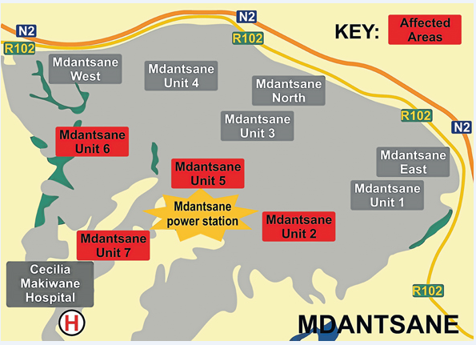
Source: Dispatchlive.com

The study site was Mdantsane township, under the Buffalo City Municipality, in the Eastern Cape province of South Africa. The researcher did a survey of Mdantsane zones, which reflected that in each zone or unit, as it is familiarly known, there was a business either operated by a South African or a foreign national, or two or more businesses competing for the same market of consumers. Most of business operators approached indicated their willingness to participate in the research, except for one Chinese national who rented a shop from Mr Guzana, in NU14 (reflected in picture 9, as Hlongwane supermarket). He referred the researcher to the landlord.

During the in-depth interviews, the researcher attempted to understand the bigger context and record rich and detailed information; he did not only try to understand participant responses but to engage at a deeper level that involved a high degree of concentration and constant probing into issues such as, in the case of foreign nationals, reasons for leaving their birth places, journeys into strange lands, business challenges and other experiences such as xenophobia.

Interviews took place at times convenient to interviewees, some during business hours, and others in the evening, in homes of interviewees. An interview guide was developed as a guiding tool for less formal conversation that arose during the interview process. This research tool was designed in a manner that allowed for the documenting of more qualitative type of data, such as narratives about how operators accumulated capital to start businesses. The key questions set as interview guide are attached at the end of the document.

3.5.3 ETHICAL CONSIDERATIONS

According to Bill Dutton (2010), the Economic and Social Research Council (ESRC) highlights six key principles of ethical research that should be addressed whenever applicable. The six principles are as follows: the research should be designed, reviewed and undertaken to ensure integrity, quality and transparency; research staff and participants must be informed fully of the purpose, methods and intended possible uses of the research, what their participation in the research entails and what risks, if any, are involved; the confidentiality of information supplied by research participants and the anonymity of respondents must be respected; research participants must take part voluntarily, free from any coercion; harm to research participants must be avoided in all instances, and the independence of research must be clear, and any conflicts of interest or partiality must be explicit.

To ensure that the above principles were adhered to in the research, the researcher started by briefing; an interview with the research participant providing an opportunity for the researcher to reveal the deceptive aspects of the study and for the participant that had any questions about the study, answered. All participants were informed of what was expected of them during the research process and what the research involved before they consented to participate in the research process. The participants were assured that participation was voluntary and that the subject might withdraw at any given time without penalty involved. Research subjects were assured that the information they provided would be held in confidence and that the risks and benefits of participation were disclosed.

South African interviewees agreed that their names may be disclosed, but the researcher preferred to use pseudonyms for the foreign nationals for their own safety. Since most foreign business operators rent buildings from former South African owners, names of businesses and their street addresses were written down, but pseudonyms were used for the foreign operators. Photographs of business buildings where foreigners operate were also not included in the research, to protect them from being identified. The researcher also noticed that Somali nationals have common names such as Mohamed and Abdool.

3.5.4 NOTE TAKING, FIELD DIARY AND VOICE RECORDER

Recording participants voices ‘verbatim’ also played a key role during the research process, as it allowed for confirmation, and crosschecking to occur outside of the field work context. Note taking had to be done every time an interview was conducted; sometimes a Dictaphone would be used to capture participants’ stories (where allowed). Voice recording had much value in terms of supplementing note taking and for the verification purposes.

Semi - structured interviews as described by Holloway Immy and Wheeler Stephanie (1995:55) allowed the participants to speak at length in details in ways in which they were comfortable. Daily activities of consumers and business operators were observed and recorded.

3.5.5 DATA PROCESSING AND ANALYSIS

The process of data analysis is a non-numerical way of examining and interpreting of data in order to elicit meaning, gain understanding and develop empirical knowledge (Babbie E. 2007:378). Upon completion of each in-depth interview, the information was captured in Microsoft Word, as most of the responses were narratives. To prepare for data analysis, data for each phase was captured separately; responses to questions referred to in the Methodology for each phase were analysed, looking at the prevalent responses and exceptional ones, so as to be able to draw a conclusion based on the analysis. In analysing data, this research has adopted the concept known in qualitative research as “thick description,” (Henning Elizabeth and Smit G.J. 2004) which gives an account of an occurrence that is firstly coherent and that secondly gives more than facts and empirical content, and lastly, interprets the information in the light of other empirical information in the same study.

CHAPTER FOUR

PHASE 1 OF THE BLACK COMMERCIAL MIDDLE CLASS IN MDANTSANE (1967 – 1979)

4.1 INTRODUCTION

This chapter is presenting findings on the business operations of the Black Commercial middle class of phase 1 in Mdantsane, between 1967 and 1979; looking at their business achievements and their deteriorations. The Group areas Act, Act No 41 of 1950 forced physical separation between races by creating different residential areas for different races in South Africa. It is in this context that Mdantsane was established, and Black people were removed from East and West banks in East London, to pave way for the implementation of this Act. Business owners in the so called “wrong” areas were given notices to move away, failing which their business premises were bulldozed to pave way for the planned development. Most of business owners who operated in those “wrong” areas had to make quick decisions about their businesses to avoid losses and destruction (Dauda, C.1996:2).

Mdantsane was built according to Native Units or Zones, beginning with Native Unit One and Native Unit Two (see figure 4 on page 25). In these Native Units the government also built business complexes where people could rent business premises

4.2 THE EVOLUTION IN PHASE 1

The Black Commercial middle class of phase 1 refers to the first people who operated businesses in Mdantsane, immediately after its establishment. There were two categories of business people who firstly moved to Mdantsane to open up businesses; some saw the move as an opportunity in a new business area where there would be less competition and where they could apply monopoly, and apply self-mark ups, exploiting the distance between Mdantsane and East London. Others went to Mdantsane under pressure because their business structures in East London were on the verge of being destroyed, as they were regarded to be on “wrong” places. Phase 1 therefore consists of both voluntary and forced business operators.

For this phase, the study has interviewed eight business operators (Mr Dyobiso, Mr Gabelana, Mr Gaxela, Mr Mpendu, Mpepho, Mr Mvemve(Ntsikane), Mr Qhinga, and Mr Saule) who were the first to operate businesses in Mdantsane, but with a particular reference to the case study of Mr Gaxela and Mr Gabelana. The study looks at how each accumulated the initial capital to start his business, his business background, his level of education, conditions that were favourable for business success, his business operation, and his business challenges that may have led to business deterioration. Some of these business people moved beyond 1979 up to the late 1980s, but are classified under phase 1, since they were business pioneers in Mdantsane. Most of phase 1 members started their businesses through their savings and hard work.
From the interviews conducted with phase 1 members, not all of them got loans from the banks or co-operations; some accumulated their start-up business capital from their work savings and additional money making methods, such as the money loaning system practised by Mr Ntsikane at Car Distributors Assembly (CDA). Most of them did not have business academic qualifications; they learnt from self-taught experience, through trial and error; they gained experience through various ways, for instance, Mr Qhinga was usually asked to manage one business when the owner was away. He took advantage of this and equipped himself with the requisite skills of running a business. So when he had enough capital, it was easy for him to start his own enterprise which became successful. Out of eight members interviewed, six had attempted business before coming to Mdantsane; Saule had a spaza shop at Dukashe Street. Although it was not an experience based on an academic skill, it became a motivational force to them, to open up businesses in the newly established Mdantsane. Others were under pressure because their businesses in Tsolo and East Bank were threatened by the new legislation which gave them time frames to vacate or their businesses will be destroyed.

The initial success of phase 1 members can be attributed to the pull factors that prevailed in Mdantsane then. According to the information shared by phase 1 interviewees, in 1967 Mdantsane was a newly established township, without any existing businesses. Business owners had a bigger market to sell to, and believed growth would come on its own time. The distance between Mdantsane and East London also played a favourable role for phase 1 members; it made it difficult for consumers to travel to East London for their daily needs, thus they opted for closer businesses in Mdantsane. The transport system also contributed to the rise of Mdantsane Black Commercial middle class; it was limited to buses and trains. Buses were dropping commuters at the Bus rank (Highway), and commuters had to travel on foot to their respective units, as a result this was making the commuters vulnerable to criminals (Tsotsis). The commuters were therefore reluctant to carry stuff from town; they preferred to buy them from local businesses. The railway line from East London to Mdantsane also put commuters at a disadvantage because it ran outside Mdantsane, therefore commuters were reluctant to buy stuff from town and carry them to Mdantsane by rail, because that would be a burden to them (commuters) from the station to their houses. Railway transport was the cheapest mode of transport then, as a result it was always over crowded, and commuters had to squeeze their way into full carriages, thus it was not suitable for people with heavy items or groceries. For its own safety and convenience Mdantsane community had to buy from local shops, except the few that had private transport.
Another contributor to the initial success of the phase 1 members was co-operation amongst them. Co-operation was brought by the fact that all of them came from East and West Bank, and they were faced by the same challenges. They assisted one another in terms of information sharing, reconciliation of books, and solving any problem that inhibited their business growth. To eliminate competition amongst them, prices were agreed upon (price fixing). The fact that Mdantsane and its residents were products of apartheid laws solidified their unity; business people and consumers saw themselves as having one common enemy. Consumers sympathised with the loss incurred by business people in West and East Banks and were therefore willing to support them, thus turning the entrepreneurship factor into a political factor. Their economic growth after few years in Mdantsane is reflected by their movement from rented government buildings to new business sites that they owned.
Similar business operations applied to all business owners between 1967 and 1979; they bought their stock from East London retail shops. Mr Mpepho reported to have bought grain related products from Epol, in West Bank and Pullins in town, whilst Mr Mpendu mentioned Weirs and Metro (2014/07/30). Mr Mpendu stated that,’ the only deliveries that were done in the township were Dairy, Bakery and Coca Cola, the rest had to be bought and collected from East London (2014/07/30). All members of phase 1 in Mdantsane did their banking in East London because there were no financial banks in Mdantsane. Phase1members applied a similar marketing strategy of issuing food items on credit to the loyal customers. Some like Mvemve included free delivery, Xmas and New-Year parties, and cashing cheques for civil servants. Phase 1 members reported to have had book keepers; Mr Qhinga argued that he would hire a book keeper who sometimes would take his business books to whites in town, and Mr Mvemve’s book keeper is said to have been Mr Mkosi.
Phase 1 Black Commercial middle class members in Mdantsane stated that they have been affected by the political disturbances in the late 1970’s and late 1980’s, which included bus boycotts and the final overthrow of Lennox Sebe (the life president of Ciskei homeland). Those who survived the disturbances of late 1970’s, stated that their final straw came in 1990 during the overthrow of the government of Lennox Sebe by Brigadier Oupa Gqozo. Business owners mentioned the 1983 Mdantsane bus boycott and the overthrow of L.L. Sebe in 1990, as what affected their businesses in different ways. The 1990 political disturbance seemed to have affected both phase 2 and the remnants of phase 1 members. It would be assumed that before those political disturbances, their businesses were doing well. The 1983 Mdantsane bus boycott came about when workers resisted the increase of bus fares by 11 percent. When it escalated to the full boycott, business owners were affected in different ways depending on the locality of their businesses.
The second political factor that is regarded as the final blow to Mdantsane businessmen is the overthrow of Lennox Sebe, the then president of the Ciskei homeland by Brigadier Oupa Gqozo in 1990. This led to lawlessness, resulting in the looting and burning down of businesses. Initially, this destruction was directed to those businesses associated with the government, but later a criminal element joined, and even those businesses that had nothing to do with homeland government were burned and looted. Not all of phase 1 and 2 businesses were insured; those who were fortunate enough to be insured were either insured for stock or the structure but not for both. Since most of those insured were insured for the stock, they received little compensation, and had to try other means to rebuild their businesses, thus going for loans from financial institutions. Mr Mpendu, for an example, was compensated only for the stock, and had to sell his NU6 house in order to rebuild his supermarket in NU8.The success of phase 1 members was due to business experience, hard work, co-operation amongst business owners, minimal competition and the support of Mdantsane consumers. Even the government of the day relaxed some of the regulations in Mdantsane to encourage people to see Mdantsane as a beneficial place in which to live and do business.

This can be deduced from Gcinikhaya, ( Mr Mpepho’s son) who stated that “there were no fixed trading hours in Mdantsane, we had to accommodate people who were working morning shifts, who wanted to buy some stuff before going to work, therefore we used to open at 6am and close at 20h30” (2014/06/21).This was also echoed by Victor (Mr Dyobiso’s son) who stated that, “they used to open at 5am and close at 21h00, catering for people going to the train station, who usually bought fat cakes and fish as a form of work lunch.”(2014/11/13). It may be said that these relaxed regulations contributed to the gradual growth of business owners in Mdantsane. The early opening and manual banking demonstrate that the crime rate was low.

4.3 CASE STUDIES

4.3.1 A CASE STUDY OF MR K. GAXELA

According to Linda (Mr Kaiser Gaxela’s daughter) Mr Gaxela accumulated his business capital while working in Cape Town, and when he came back to East London, he opened a fruit shop in Tsolo location in 1952, and later a general dealer behind Rubusana Street in the same location. When he went to Mdantsane in 1967, he had business experience exceeding fifteen years that is why he was able to quickly rise in Mdantsane. Both Mr Gaxela and Mr Gabelana started with fruit shops because fresh produce licence was the easily available option for Blacks during that time. When he arrived in Mdantsane, he ran a shop from a rental building in NU1 (Picture 1). They were amongst the pioneers of the Black commercial middle class in Mdantsane. According to Linda, business boomed in NU1 shop because of his father’s hard work and business experience, to an extent that the bus stop next to the building was and is still named after Mr Gaxela. They also sold paraffin, a commodity that was highly demanded by the Mdantsane consumers. In 1974 Mr Gaxela moved out of the government building in NU1 (Picture 1) and bought a site in NU5B where he built his own structure consisting of a bottle store called ‘Nonasi’, named after his wife, and a shop next to it (2014/6/21) .

Picture 1: The first business building in Mdantsane where both Mr Gaxela and Mr Gabelana rented business premises
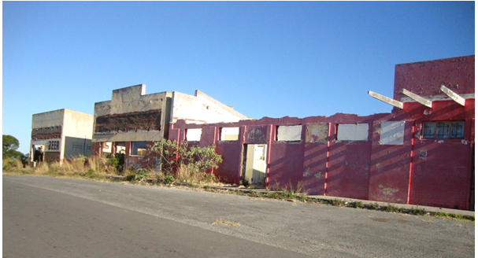
Source: Author (21/6/2014)

Picture 2: A Bottle Store and a Shop built by Mr Gaxela in NU5B

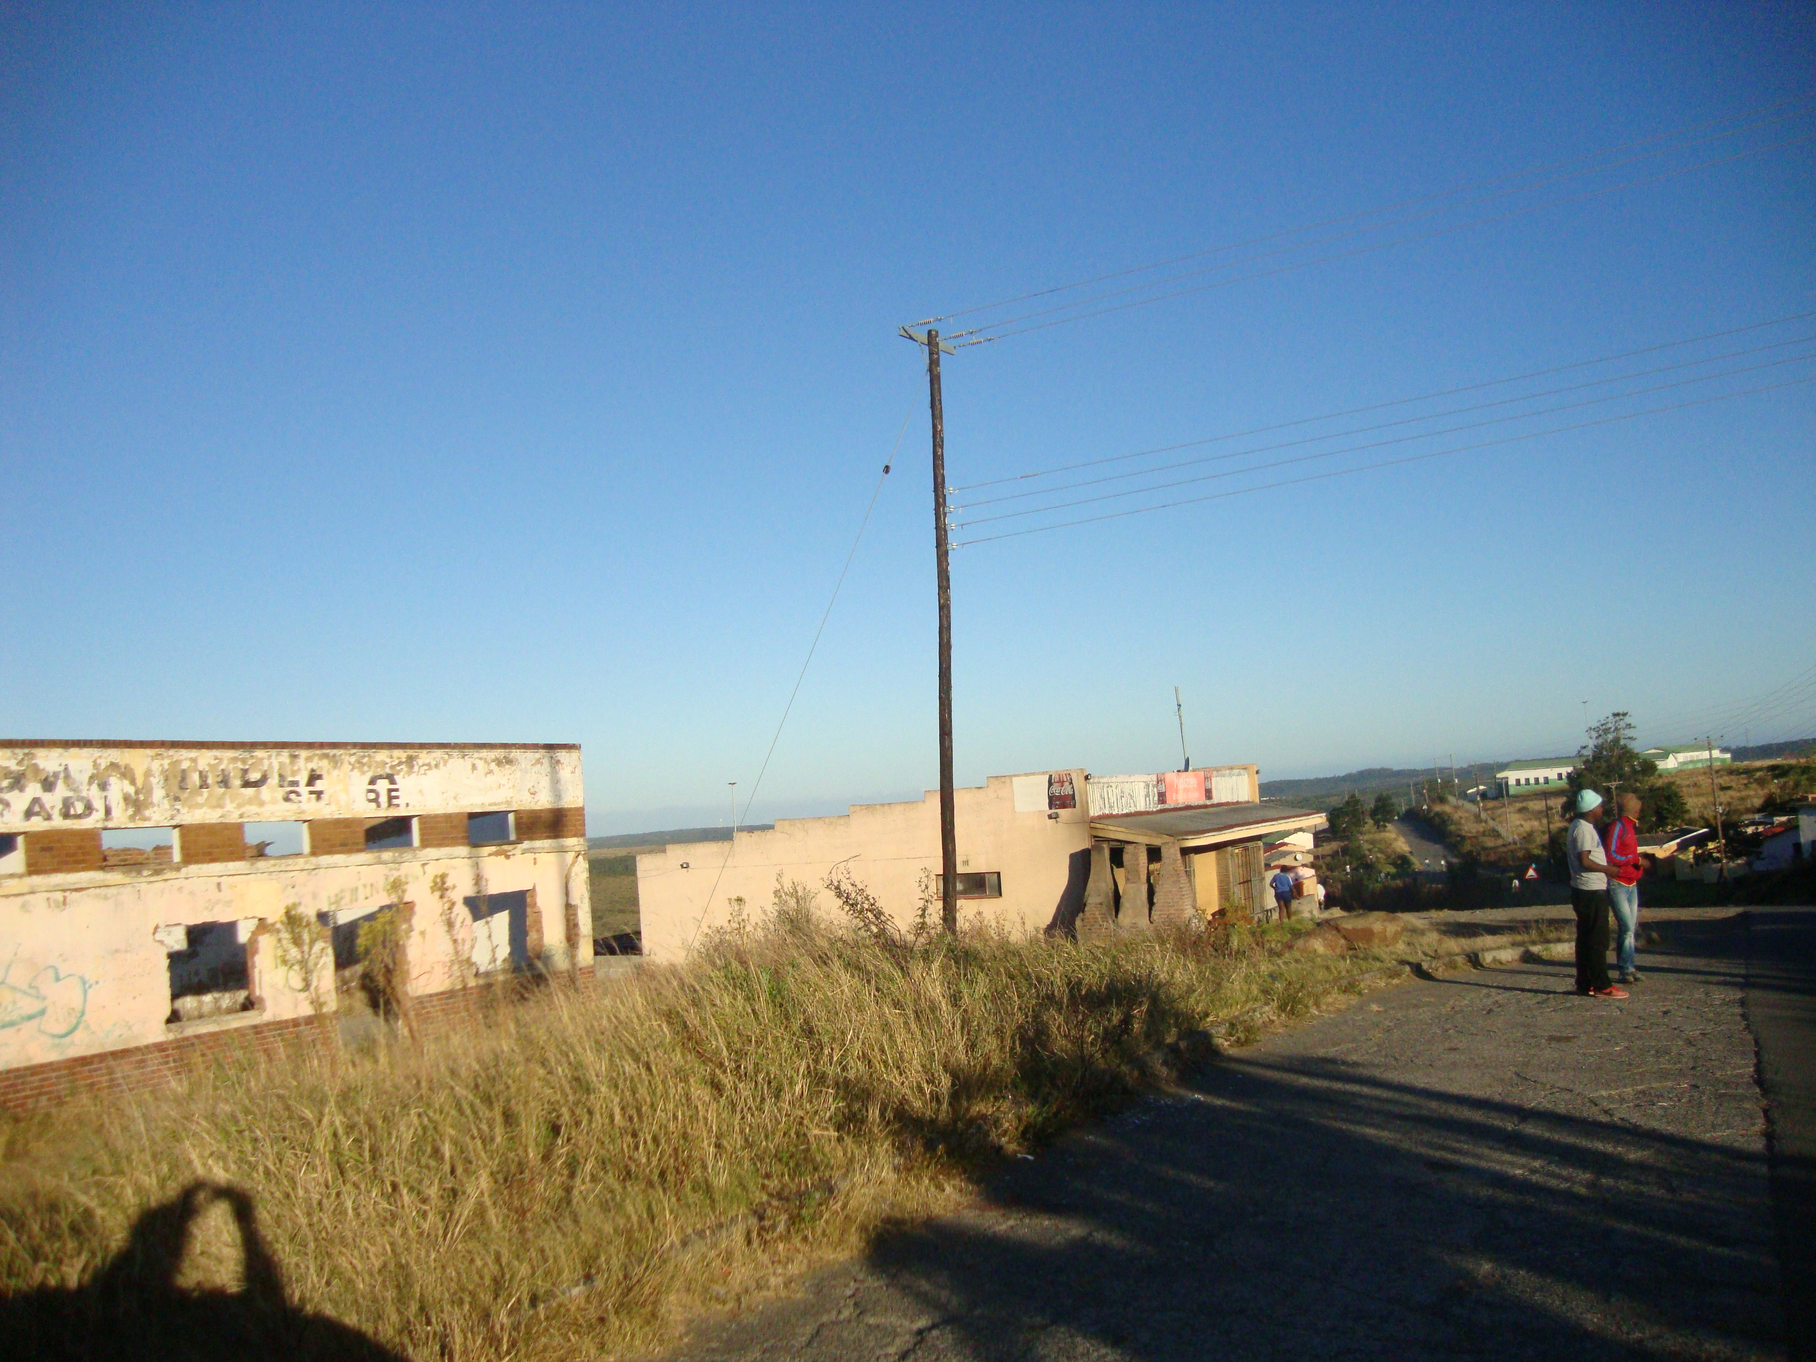

Source: Author (2014/6/21)

According to Linda this was the first bottle store in Mdantsane, and it supplied all the Taverns in Mdantsane and surrounding areas. Mr Gaxela bought delivery vans to meet the local demand, thus saving time and money for tavern owners, and contributing to the rise of popularity of his bottle store. Most of the workers employed were family members; the shop was run by Mr Gaxela’s wife, while the bottle store was under the care of Mr Gaxela and his elder son (Mxolisi). Those who were attending school were also required to come and assist after school and during the weekends, as the demand for services was high.

During the study, the bottle store was a skeleton of what it used to be; an empty building that has been vandalised whilst the shop is kept operational by a foreign national. Linda blames the change of fortunes to the 1990 political uprising. She stated that her father, being a friend of Lennox .Sebe, his businesses were the first targets of the burning and looting. Mr Gaxela tried to resuscitate the business after the 1990 coup but business was poor because people had already learnt how to survive through mushrooming spaza shops and taverns. This new competition and poor business performance forced him to rent the business out. According to Linda the loss incurred by Mr Gaxela resulted in poor health that deteriorated until he died in 2003. The sad part is that the building is still owned by the family but they are unable to make a living out of it, thus Linda survives on her teaching salary to feed her children and the surviving younger brother.

4.3.2 A CASE STUDY OF MR ERIC GABELANA

According to Mr Gabelana’s son Thoza (2014/9/4), his grandparents had a shop in Tsolo village, and that is where his father (Eric) had his business background. When he (Eric) moved to Mdantsane he started by selling bread and drinks to construction workers during the process of constructing Mdantsane as a township. From such earnings, Mr Gabelana was able to rent business premises from the first business building to be built in NU1, for black businessmen to rent (Picture 1). This is the building he shared with other entrepreneurs such as Mr Kaiser Gaxela running a shop and Mr Mginyana running butchery. He ran a Fresh produce shop, but he later included daily needs like milk and bread, thus later his Fresh produce licence was converted into a shop licence. According to Thoza, business boomed in NU1 because there were no competitors; with high demand and low supply, things ran in their favour. Mr Gabelana ran the NU1 shop from 1968 until 1973 when the criminals burnt it, but he managed to rebuild it without getting help from the Xhosa Development Corporation (XDC).
In 1973 Mr Gabelana moved out of the government building he shared with Mr Gaxela in NU1 (Picture 1), and bought a shop from Mr Hoyi in NU2. He started to use a trading name called, ‘Enothole’, as a symbol of ownership. This can be seen in all the buildings he owned in his entrepreneurship reign (Picture 3, 4, and 5).

Picture 3: The remains of a shopping site bought by Mr Gabelana
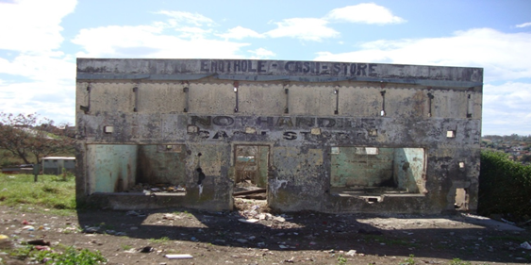
Source: Author (23/8/2014)

Mr Gabelana is one of phase 1 members of the Black commercial black middle class in Mdantsane who operated even during the homeland system (Phase 2). In 1981 he ran a hotel for three years in the town of Peddie, between King Williams Town and Grahamstown in the Eastern Cape, South Africa. The hotel business also boomed because it was the only hotel in Peddie. In 1984 he stopped running the hotel, because of political pressure from the Ciskei government; he stated that they wanted his Eric to partner with a government official by force. He later bought a site in Mdantsane Highway in 1983 with a R200 000 loan. Thoza (Mr Gabelana’s son) stated that the loan was paid within two years. After the buildings were completed, Mr Gabelana returned to Mdantsane to run the Highway complex full time. (See picture4 & 5). According to Thoza, business went well in Mdantsane between 1986 and 1988; the family ran a Health centre, a Bottle store, and Chicken Licken franchise, rented out other premises in the form of offices to doctors and as a boxing gymnasium. Mdantsane being regarded as a Mecca of boxing, and Mr Gabelana being the first boxing promoter to promote the then popular local champion, Nkosana Mgxaji, the boxing gym was always in demand. (Thoza 2014/9/4)

Both picture 4 And 5 reflect the rise and fall of Mr Gabelana as a member of the Black Commercial middle class, of phase 1 and phase 2. He was able to rent at a government building from 1968 until 1973, moved to a shop in NU2, moved out of a small shop (Picture 3) and built a new complex (Picture 4 & 5). The site for picture 4 and 5 was bought in 1983 but the buildings operated from 1985; they were built during the homeland system through the use of a loan. Mr Gabelana, whose business had been situated at Highway bus rank, benefited during the 1983 bus boycott; Thoza argued that the 1983 bus boycott compelled most people to buy from Mdantsane.
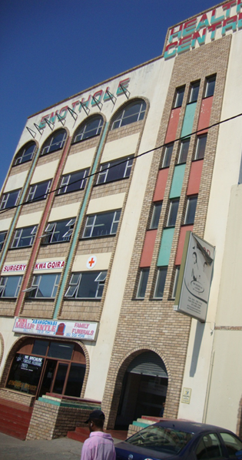
Picture4: Part of the complex built by Mr Gabelana at Mdantsane Highway.

Source: Author (4/09/2014)

Picture5: Part of Mr Gabelana’s building built at Highway in Mdantsane

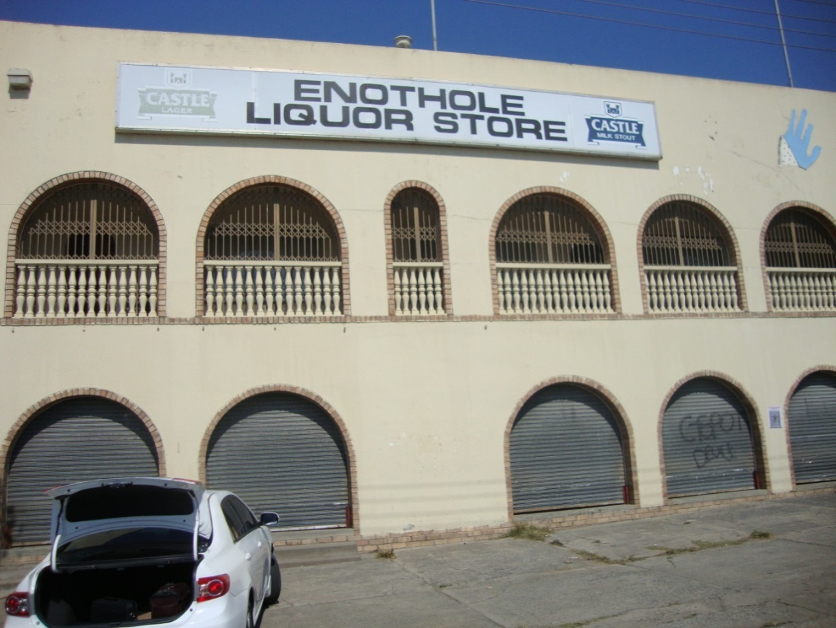
Source: Author. (4/9/2014)

Thoza like most members of the Black Commercial middle class in Mdantsane attributes his father’s fall to the 1990 political upheaval, where his father’s businesses were looted and burnt down. The effect of the 1990 burning and looting was that people got accustomed to buying from town. According to Thoza, affected Mdantsane businesses established a committee to go to the Ciskei National Development Corporation to request to be given a breather to refurbish their business structures, but the government refused. Fortunately for the Gabelanas, their buildings were insured, and were able to rebuild their structures, but had to loan again to stock their businesses.
During this study, the buildings were a burden rather than an asset, with Thoza unable to run and maintain the buildings, blaming the government for failing to support local Black business people. To him, the Eastern Cape Development Bank (ECDC) stopped being a development bank, when it failed to cancel their debts, even after the new political dispensation of 1994.
To Thoza, instead of helping them, the government worsened their situation, quoting competition from the Taverns that were allowed to buy from South African Breweries, and from distillers; big boys(liquor outlets like Crazy J and Big Daddy) were allowed to trade inside the township and compete with small boys like their bottle stores. Also citing big national retailers like Checkers, Boxer, and Spar, all put in Highway, as a strategy of the external forces to destroy the Black Commercial middle class in Mdantsane. His closing statement reflected his loss of hope: “Black South African business owners of Mdantsane are in the mud, calling or waiting for a helping hand from outside to rescue them; they are stuck with their business structures, a fertile ground for foreigners to take advantage of’’ (2014/9/4). This he stated to be the reason why most of them have decided to rent their structures to foreign nationals, so as to sustain them through rental.

4.3 CONCLUSION

Today all that is left from the Black Commercial middle class of phase 1 are derelict buildings that are being rented out as office spaces or business sites. The buildings had turned out to be burdens to the children of former owners; they cannot use them as business sites due to their limited finance. The 1990 burning and looting seemed to be a reason for the fall of every businessman who operated during that time. They argued that Mdantsane should have been declared a disaster area, and they ought to have been compensated by the state. They all blamed the African National Congress government for their plight, arguing that the government refused to compensate them, although their losses were an outcome of a political action.

CHAPTER FIVE

PHASE 2 OF THE BLACK COMMERCIAL MIDDLE CLASS IN MDANTSANE. (THE HOMELAND SYSTEM 1980 -1994)

5.1 INTRODUCTION

By 1980 the South African government had succeeded in its efforts to implement the homeland system, an extension of the separate development, where Black Africans would be assigned ethnically to their own impoverished homelands and thus leave the white minority in control of the economic wealth of “white” South Africa (The Christian Science Monitor, September 9, 1992). The idea behind was to grant political independence with the promise of separate-but-equal status; an attempt initiated by Prime Minister Hendrik Verwoerd to morally justify segregation. In terms of this vision, all black South Africans would acquire citizenship of an independent homeland but would be denied political rights beyond their homelands (The Christian Science Monitor, September 9, 1992). The situation in the Eastern Cape Province was unfortunate because it had two homelands separated by the Kei River (Transkei and Ciskei). By 1980 Transkei had already declared its independence from South Africa, a development that began as early as 1976, and Ciskei was to follow in 1981. Resistance against apartheid legislation increased with each and every effort of the government’s implementation strategy, thus a lot was done by the South African government to entice people into seeing benefits from accepting the homeland system. In each homeland there was a development corporation to promote Black business ownership; the corporation would issue out loans to Black business entrepreneurs, hold workshops and trainings for business owners, and allow them to operate a separate system of taxation. It is under this business environment that phase 2 Black Commercial middle class members operated between 1980 and 1994; joining the phase 1 operators who by that time had already established themselves, as successful business people.

5.2. THE EVOLUTION IN PHASE 2

For this study, phase 2 of the Black Commercial middle class in Mdantsane refers to the entrepreneurs who, as the township grew, saw opportunities to join phase 1 Black commercial middle class operators. They differ from phase 1 members because when they joined, business infrastructure was already in place, and Government support through development corporations was accessible. Among those interviewed for the study are: Mr Nomtshongwane, Mr Kwakweni, Mr Soxokashe, Mr Guzana, Mr Toyana and Mr Tanana. The gendered nature of these businesses reflects that entrepreneurship in Mdantsane was a male dominated sector. It was the growth of the Black Commercial middle class of phase 1, and the easy access into business created by the homeland system that led into phase 2 members joining entrepreneurship. Some members of the Black Commercial middle class of phase 2 were better educated, and had worked for the corporate business before establishing their businesses. Both Mr Tanana and Mr Toyana had previously worked as Sales Representatives for Leaver Brothers and United Tobacco respectively (2014/06/ 22). The Black commercial middle class of phase 2 built on the models of phase 1 members; rented business premises created by the growth of phase1 members who moved out of the rented premises and bought new business sites to build and run their own businesses, thus they operated with the phase 1 operators, but were new to business. Mr Nomtshongwana and Mr Guzana are examples of phase 2 operators who started their businesses on rental apartments, and whose business buildings were not destroyed by the 1990 political upheaval. The movement of business operators from rental apartments into buying their own business sites reflects the growth and confidence they had in the businesses they operated, and the absence of strong competition, accompanied by the lenient business regulations of the homeland system.
The two bottle store owners, Mr Toyana and Mr Tanana, had marketing experience because both had worked as sales representatives for different companies. According to Mr Tanana, it was this experience that encouraged them to go into the liquor business. Mr Toyana operated a bottle store at the Ciskei National Development Corporation building in NU9, while Mr Tanana operated his bottle store and butchery at another CNDC building in NU11. For the purpose of this study, two case studies will be examined, that of Mr Nomtshongwana and Mr. Guzana. Mr Nomtshongwana is still in business, and Mr Guzana is the last to recently exit the supermarket business in 2014.

5.2.1 REASONS FOR THE RISE OF THE BLACK COMMERCIAL MIDDLE CLASS IN PHASE 2

Various factors came out as reasons for the success of the Black Commercial middle class of phase 2; they included monopoly system, appropriate timing, and business location.
Mr Tanana argued that, “the first business people like Kaiser Gaxela, Norman Zitumane and Sisa Dukashe were doing well, because no business was confiscated through their incapability, but they were not operating at the level where they would be doing, had they had the necessary business skills.” He went on to argue that, “Mr Gaxela, Mr Zitumane and Mr Dukashe had monopoly, and had practised self-mark ups, exploiting the distance between Mdantsane and East London” (2014/8/23).

Asanda,(Mr Toyana’s daughter) attributed the success of her father’s bottle store business to the fact that it was among the first bottle stores to be established in Mdantsane, and its proximity saved tavern - owners time and money. According to Asanda, her father’s marketing strategy was based on prompt free delivery; he had a fleet of panel vans to deliver at any time of the day.

Among the favourable conditions that prevailed for Mr Soxokashe’s spaza shop were its location, the lack of competition, the homeland system of regulating business, and the inclusion of paraffin among the items that he sold. His spaza shop was closer to the first high school (Mzomhle) in Mdantsane. Mzomhle High School’s academic popularity attracted large numbers of students from all over the Eastern Cape; they relied on his spaza shop for their lunch requirements, and that boosted his business. The homeland regulation system was not strict on unlicensed business operators; spaza shops were able to operate freely, and there were no fixed hours of business operations, as a result spaza operators were able to operate without fear of police harassment.

5.2.2 REASONS FOR THE FALL OF THE BLACK COMMERCIAL MIDDLE CLASS IN PHASE 2

Vuyolwethu, (Mr Kwakweni’s daughter) cited two challenges, namely, the failure of the government to help those businesses affected by the overthrow of government, and laziness among black South Africans. She (Vuyolwethu) argued that the laziness had been created by the dependency syndrome on government, created by false hope raised by the ANC government when it campaigned for the 1994 elections. This dependency on government, she argued, disempowered Black businessmen in Mdantsane. To her, the government’s “Vukuzenzele” campaign during Mbeki’s era was an acceptance of its failure to fulfil its election promises (2014/08/23). According to Mr Tanana, challenges faced by Mdantsane black businesses could be attributed to factors such as their level of education, price competition, the 1990 disaster, high crime rate after 1990, the unresponsiveness of the government to the pleas of Mdantsane black business owners, and failure of black business owners to equip their children with business skills. To Mr Tanana, the literate ones were able to grab the opportunities that were provided by the homeland government.

This could be deduced from his statement:

‘The homeland government promoted Black Business empowerment;
through Ciskei National Development Corporation; workshops were held,
to train Black business operators, and those trained were followed up
to check their progress, but the problem was illiteracy;
Black business operators had no business basic skills’
(Mr S. Tanana 22/6/2014).

On the 1990 disaster, Mr Tanana argued that the Black Commercial middle class had difficulty in rebuilding their businesses because the government failed to assist them, creating emotional scars to Mdantsane business operators. According to Mr Tanana, the end result was the mushrooming of unlicensed businesses after 1990, something which knocked out even those who were trying to revive their businesses, arguing that unlicensed businesses did not pay tax, while the wounded business operators continued to pay tax. (2014/08/23).
Asanda (Mr Toyana’s daughter) echoed the same reasons, citing competition and the government’s failure to assist affected businesses after the 1990 disaster. Asanda stated that even before the 1990 disaster, her father’s business was affected by competition created by liquor outlets that were put closer to the township, and also by the issuing of liquor licences to retail shops like Shoprite/ Checkers (2014/6/22).

5.3 CASE STUDIES

5.3.1 A CASE STUDY OF MR NOMTSHONGWANA

Mr Nomtshongwana started by renting an apartment that was left by Mr Gaxela. Mr Nomtshongwana stated that during that time, the cost of living was low, citing the fact that he replenished the stock with an amount of R60.00, without any government assistance (2014/06/21). Between 1976 and 1978, Mr Nomtshongwana ran a shop business in two rental business sites, moving from one rental apartment to the other. Both rental apartments were in NU1; the first one being left by Mr Gaxela, and the second one being left by Mr Dyobiso. Between 1978 and 1984, he diversified and rented a funeral parlour apartment on an ECDC building for R350 a month. For this he claimed to have been assisted by the ECDC with a R12000 loan. In 1978, while Mr Nomtshongwana was a councillor, and a chairperson of business councillors, he applied three times for a site to open a funeral parlour in NU8, but was turned down. The focus of the government was to encourage people, not councillors, to apply for businesses. In 1980 he used his brother in law to apply for a shop business site in NU1, and was approved in 1989. He built his own shop not far from the shop apartment he rented from Mr Dyobiso. The shop in NU1 is still operating but is currently (2015) run by foreign nationals.

Picture 6: A shop built by Nomtshongwana in NU1

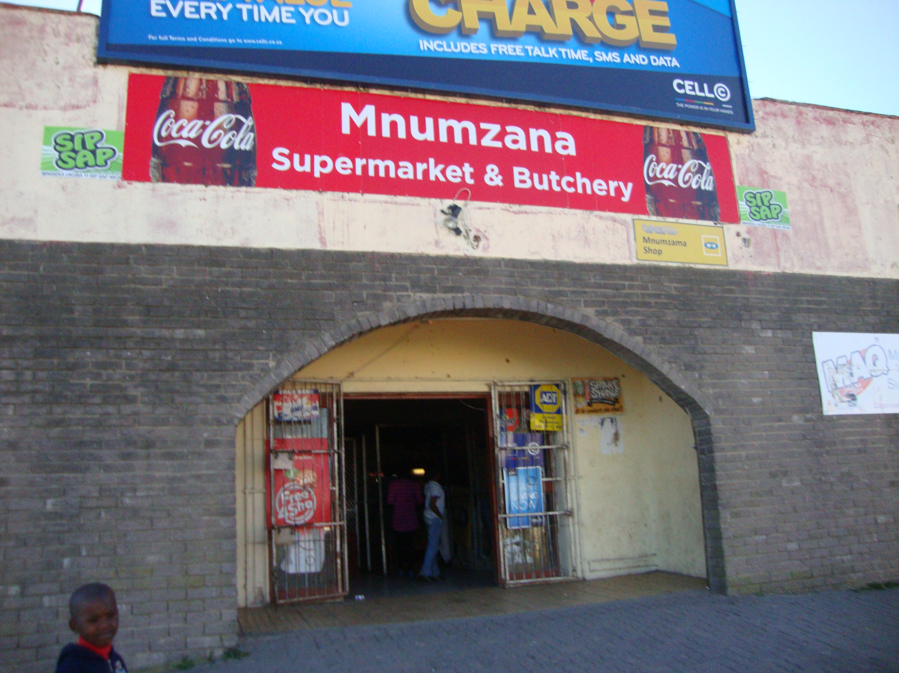
Source: Author (2014/6/21)

It was only in 1991, after the intervention of Mr Ngcofe from the Department of Interior that his application for a funeral parlour was approved. He started building the funeral parlour from his own pocket in 1994 and it began operating in 1997.
According to Mr Nomtshongwana business was booming in the 1990’s, he claimed that KSM trucks were moving in and out of Mdantsane bringing orders. He would order more than 500 bags at a time, and they wouldn’t last long. Various challenges were brought forward by the interviewees during the research process. Mr Nomtshongwana cited the harassment by the Ciskei government, arguing that anyone who was seen to be against the Ciskei government was detained and sometimes deported. Mr Nomtshongwana is one of the people who experienced those Ciskei detentions in August 1978. Both the members of phase 1 and 2 of the Black Commercial middle class in Mdantsane shared in the effects of the 1990 political disaster.
During the 1990 political upheaval, Mr Nomtshongwana’s business in NU1 was not affected; he stated that it was protected by the NU1 youth who slept in it. In 1997, he left the shop in NU1 and concentrated on his funeral parlour in NU6, and on traditional medicine that he sells at various chemists.
Picture 7: A funeral parlour built by Nomtshongwana in NU6

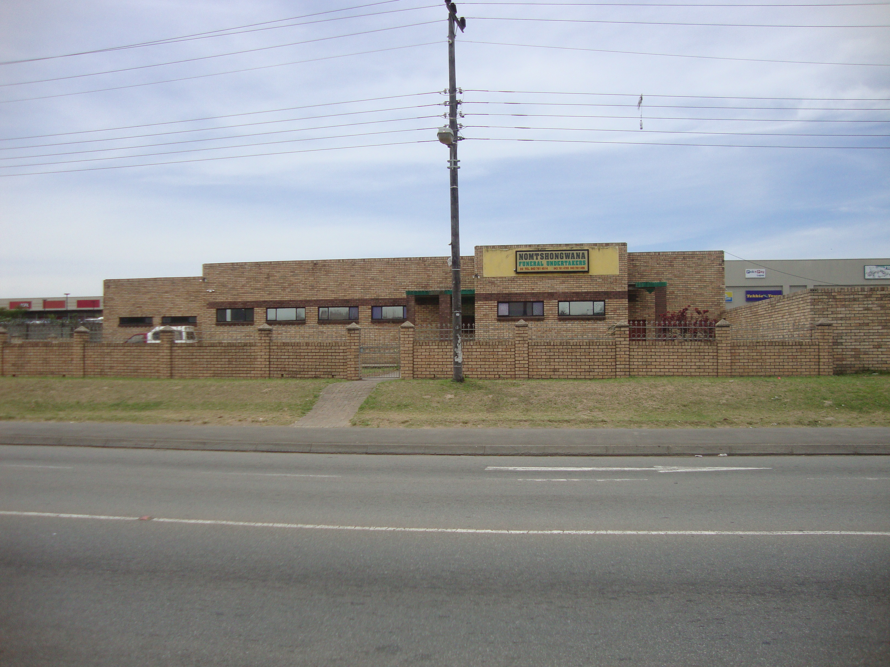
Source: Author (2014/6/21)

5.3.2 A CASE STUDY OF MR GUZANA

Mr Guzana is another example of a self-starter; he started by renting a shop from the Dyani family in NU3 for 14 years. He argued that business was booming in NU3, but he had a problem of space; his focus was to make a reasonable amount of money before opting for his own business site. He attributed his success in NU3 to his hard work, and to the fact that there was no competition; his rental shop was the only shop in the area. On the question of crime, he argued that for the 14 years he had stayed in NU3, only minor burglary and theft attempts occurred in his rental shop. This he attributed to high employment rate that East London people experienced then, and to the location of the shop; it was closer to the Native Affairs offices, that included courts and police cells. Through profit from the shop, he was able to buy a delivery van, used both for buying stock from East London, and delivering to the pensioners in Mdantsane and surrounding areas like Nxarhuni. He regards that rental period as an experience in acquiring business skills that he used when he had his own supermarket.

Picture 8: The Dyani family shop that was rented by Mr Guzana in NU3

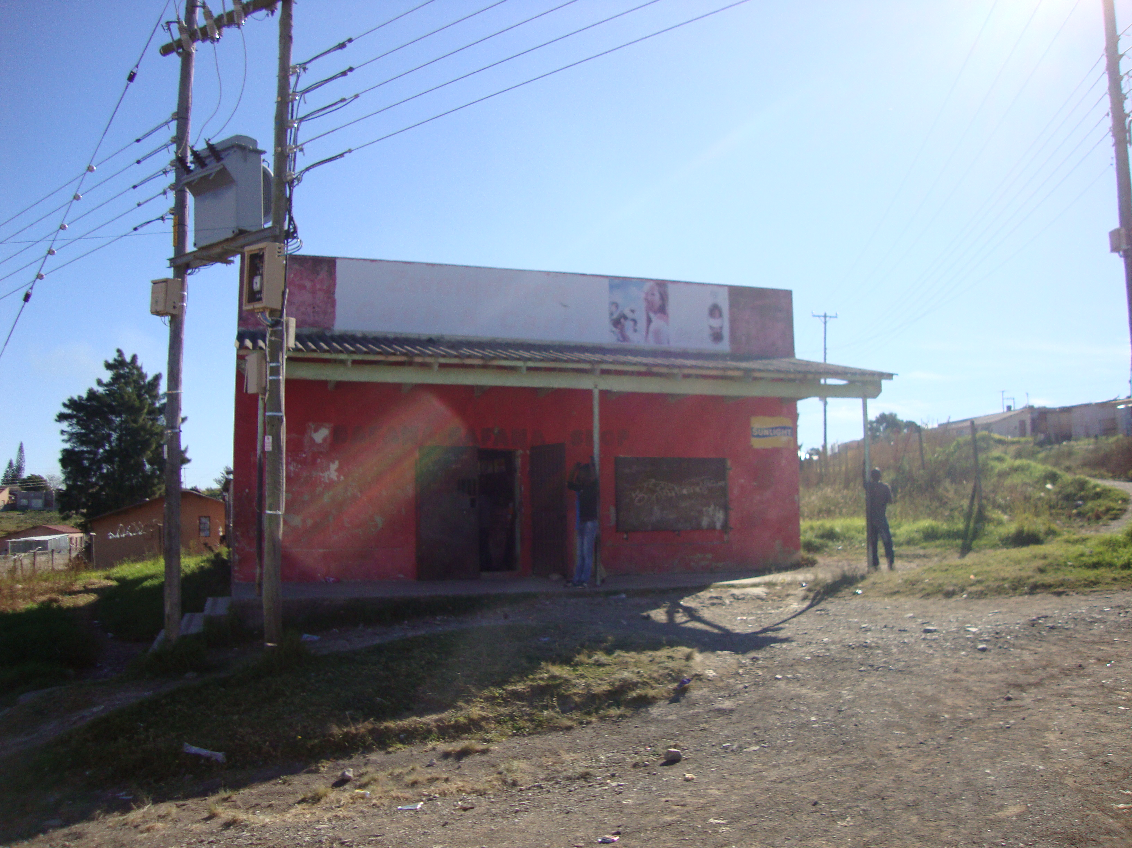
Source: Author (2014/6/22)
In 1987 Mr Guzana took an advantage of the homeland opportunities, and got the assistance of the CNDC loan to buy a site for his new supermarket in NU14. The new supermarket traded by the name of Hlongwane which is his clan name.
According to Mr Guzana, business boomed in his new supermarket between 1987 and 1990, attributing that to the lack of competition, and to his marketing strategy that always kept his supermarket full of customers, although the strategy provoked other business operators closer to his supermarket in NU14. Mr Guzana stated that his marketing strategy was to have mid-month and end of the month specials, a strategy he claimed worked for his business in NU14. That was unlike the Black Commercial middle class of phase 1 operators, who collectively agreed upon prices. The start of price competition was something that other business operators were not used to. Mr Guzana quotes a confrontation he had with an NU15 shop owner Mr Nontloko who asked him, ‘how are we going to make money when you are (Mr Guzana) slashing prices like that?’ Mr Guzana claimed to have been satisfied with R3.00 profit on the item that was in question, while other shop operator wanted to make R10.00 profit.

Picture 9: A supermarket built by Mr Guzana in NU14

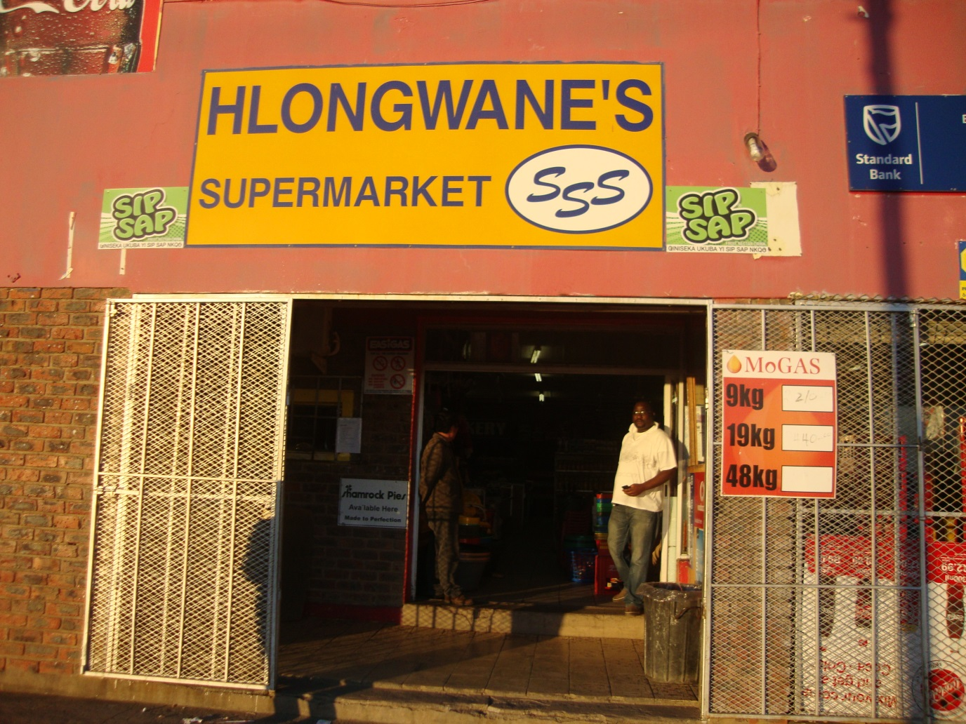
Source: Author (22/6/2014)

Among the challenges cited by Mr Guzana, was the loaning system of CNDC, citing the disproportional amount between the loan for the building and that of stock, making an example of a R130 000 loan to build a shop, but supplied with R30 000 worth of stock. To him, that was what was making it difficult for the operators to make profit and be able to pay back the loan. Other challenges, he mentioned were debt burdens, crime that has escalated after 1994, miscalculations of municipality bills, and the failure of government support through ECDC and South African Revenue Services. On municipality bills, he cited an electricity bill where he was billed R18 000 a month, as a result, he requested to be changed to pre-paid electricity, but the municipality refused. He said one time the electricity bill was R200 000 and he had to take out R36 000 he had fixed, because the municipality threatened to switch water and lights off. Mr Guzana is the last on the list to rent out his business to a foreigner. He rented out to a Chinese national who, when requested to take part on the research, referred the researcher to Mr Guzana. Mr Guzana now (2015) is concentrating on stock farming, claiming to have sold some of his stock to pay municipal bills; he claimed to have had enough of the supermarket business.

5.4 CONCLUSION

The 1990 overthrow of President Sebe by Brigadier Oupa Gqozo spelled disaster to many of Mdantsane business operators because their businesses were either not insured or only insured for stock. Their lack of business education and the homeland loaning system made it difficult for them to rebuild their businesses.
This situation made people reluctant to operate businesses in the township. Some decided to give up and others decided to remain but to take precautionary measures on their business operations. This is the condition which prevailed until 1994, when foreign nationals started to flow to South Africa, and claimed a space on South African township business opportunities.

CHAPTER SIX

THE BLACK COMMERCIAL MIDDLE CLASS IN PHASE 3 (POST1994)

6.1 INTRODUCTION

This chapter narrates how phase 1 and 2 of the Black commercial middle classes have been outcompeted by foreign nationals in Mdantsane..

Globalisation is marked by accelerated flows of capital, goods, and migration. This free movement provokes a ready response by disadvantaged labour in search of greener pastures. It is therefore a global phenomenon that immigrants try to create employment for themselves and hence generate their livelihoods. According to Koser Khalid, (2007) migrants tend to be dynamic and less reluctant to take risks than the community that hosts them, and are self- employed because of the barriers they face in the salaried jobs, such as discrimination, language and lack of proper information in the formal job market. According to Kennedy John, (1964) when a person migrates into a new country, he has to rely on his own abilities, and this makes him more flexible and innovative than he or she would be at home. It is under this context that most Mdantsane businesses are run by foreign nationals.

6.2 THE EVOLUTION IN PHASE 3

Phase 3 of the Black Commercial middle class in this study refers to business operators post 1994 elections who exploited the new political change accompanied by new opportunities. Initially, phase 3 operators included the remnants of both phase 1 and phase 2 members of the Black Commercial middle class, but were gradually taken out of business by the influx of foreign nationals. Currently (2015), phase 3 members of the Black Commercial middle class consist mainly of foreign nationals because the South African youth is not interested in opening businesses in the townships. Apartheid labelled townships as places for unwanted people, thus creating a negative attitude towards them in the minds of post 1994 youth. Unfortunately for Mdantsane business owners, the arrival of foreigners came soon after the political disaster of 1990, which involved looting and burning of businesses. In Mdantsane the majority of foreign business operators come from Somalia. According to interviews conducted with three Somali business operators in NU1, Somalis in South Africa seemed to have used the same mode of travel from Somalia to South Africa: a boat from Somalia to Mozambique, a bus to Maputo, on foot to South African borders, and a taxi to Johannesburg. They claimed to have depended on their contacts who had already established themselves inside South Africa (2014/6/21).

For this study, phase 3 has been divided into two groups; grouping of businesses has been done according to their similarities in terms of contracts signed between business operators and building owners. Long-term contracts reflect business hopes and good prospects for the future. The first being two businesses that operated in NU1, and two in Mdantsane Highway (Mr ‘Alpha’ and Mr ‘Mohammed’ in NU1, and the two of Mr ‘Arti’ in Highway); the second group being those that were operating in different units of Mdantsane (Mr ‘Jiyat’ in NU5, ‘Osman’ in NU2, ‘Ali’ in NU6, Mr. ‘Adams’ in NU3, Mr ‘Smiley’ in NU5 B and Mr ‘Abdool’ in NU3). The second group of foreign run businesses has signed different renewable contracts with the building owners, ranging between one to six years. Short –term contracts are common among those recently arrived in South Africa, as they have not yet decided where to set up their business premises. For an example, Mr ‘Osman’ who operated a grocery shop on what used to be Salinga General Dealer in NU2, had recently relocated to Mdantsane from Cape Town, and signed a short-term contract with the owner of the building. He stated that he was still studying the community that forms part of his customers, so as to be able to provide appropriate stock. By the time of the interview, he had learned that the community was poor, made up of elderly people who depended on old-age grants. As a result they bought on credit and paid at the end of the month.

For the purpose of the study, a case study of Mr ‘Alpha’ and Mr ‘Arti’ has been done; both have signed 10 years renewable contracts.

6.2.1 BUSINESS OPERATION STRATEGIES IN PHASE 3

According to Liedeman Rory, Charman Andrew, Piper Laurence and Petersen Leif (2013), an important difference between foreign run and South African run businesses is the role of social networks that enable a more competitive business model that South Africans are not used to. Liedeman et al argue that the networks provide cheap labour, contractual agreements overseen by elders, establishment of clan-based strongholds, group purchasing, and the facilitation of micro- finance through organising investments and business partnerships. South Africans, in contrast, operate within a weak social network that is often limited to members of the immediate family who provide labour but little else. Their (foreign nationals) business model is based on price competition, based on collective procurement and large distribution networks, contrary to that of South Africans, where shop-keepers would agree to maintain prices at a floor level sufficient to guarantee profitability for all stakeholders.
Among the common marketing strategies highlighted during the interviews are: familiarity with the community, and building good working relations with it; speaking and understanding the language of your customers.
Customers interviewed about businesses operated by foreign nationals, positively identified the following advantages: their businesses were within their distance, they were using a self-service system, and therefore customers could check expiry dates on the items they intended to buy. Customers also appreciated the manner they were treated by the operators, stating that they were treated with respect, and the fact that the operators could speak their language (Xhosa). One customer interviewed at “Mohammed’s” business added that the owner was helping them by converting their paper money into coins without expecting them to buy an item; something which she claimed was not possible with most of local run businesses (2014/06/21). Elderly members of the community interviewed saw these businesses as convenient places for their daily needs, without having to pay for transport; also as places they could send their grandchildren, thus saving themselves time and money.
Different foreign business operators from different units shared the same sentiments when asked about marketing strategies. These included good working relations with the owner of the building and the community, price competition and good service. Good working relations entailed assisting their communities in times of crisis, and attending their traditional ceremonies when invited. Price competition entailed slashing prices, keeping their businesses the most preferred ones in terms of prices. Good service entailed a welcoming environment, an operator always with a smile, good treatment, a place where there are always monthly specials, discounted prices and credit to those who qualify. Despite the positive aspects that the foreign business operators receive, there are also challenges that they face in the day-to-day running of their businesses.

Among “Mohamed’s” concerns were crime and the locality of the shop; he claimed to be living in fear because poverty and unemployment had escalated in the area, and that might result on desperate measures from the criminal elements. On the location of the business, he argued that it was far from the auto bank machines, whilst most customers preferred to carry bank cards, rather than hard cash. “Mohamed” saw this distance from auto bank machines as a contributing factor in the slow growth of his business, mentioning that he has already written to some financial institutions to come and install machines in or near his grocery shop premises. (2014/06/21).
Fortunately for other Mdantsane business-operators, crime seemed to be an insignificant threat; their common challenge was the illegal connection of electricity by informal settlement dwellers, the so called ‘izinyoka’ in the South African township language. Illegal connection of electricity affected them in two ways; firstly it made them lose their electricity connection, and secondly, they felt the illegal connectors were charged from their accounts. Mr ‘Ali’ who operated a shop called ‘Endaweni supermarket’ in NU6, cited an incident when they were without electricity for twenty-eight days, as a result, he had to throw away all rotten food that had required refrigeration. Mr ‘Adams’ who operated his business at Msauli Trading in NU3, claimed to be paying R700 a week for 4 deep freezers and three refrigerators for cold drinks; a payment he claimed to be expensive, and attributed the high consumption to the illegal connections.

6.2.2 XENOPHOBIA AND GENOCIDE VERSUS ISSUES OF ECONOMIC COMPETITION

It is very difficult to distinguish the criminal element attacks from the xenophobic attacks in South Africa. South Africans, especially those in the government, will refer to any attack on foreign business owners as the work of criminal elements, whilst to the foreign nationals or human rights organisations, the same attack will be viewed as xenophobic. Foreign nationals are believed to be keeping large sums of cash; and do not use financial institutions like banks, and this is what makes them to be susceptible to this type of crime. This is the argument put forward by those who attribute the attacks to criminal element. When looting of foreign –owned shops took place in January 2015, different opinions emerged. The South African Human Rights spokesman Isaac Mangena said the attacks had xenophobic motivations: “The fact that they target only foreign-owned shops has xenophobic undertones which is very concerning to us as the human rights commission” (Mangena, 2015). In the same article, Gauteng MEC for community safety insisted that the attacks were just due to criminal elements, “We want to clarify to the province and the country that these are not xenophobic attacks but criminal attacks. In the areas where this thing started, which is Doornkop and Snake Park, the situation is calm. There are areas where people are just copying from those who are involved in these attacks” (Business Day, January 22, 2015). The source of these attacks, whether criminal or xenophobic, seems to be the cause of tension between locals and foreign-operated businesses in the townships. This can be deduced from the Gauteng economic development MEC Lebogang Maile who said,

“The domination of township businesses by foreign nationals is a reality. It was raised in our meeting in 65 townships. Almost in every meeting we had, this issue was raised. But you do not need to have a knee-jerk reaction. In order to solve the problem you must be sympathetic. That is why we developed the township revitalisation strategy to deal with the plight of businesses in our townships” (Business Day Live, January 22, 2015)

In the Finweek of February 05. 2015, Buhle Ndweni argued that the 2008 attacks that started in Diepsloot and spread to other townships like Alexandra, were seen as criminal rather than xenophobic attacks, where unemployed youth took advantage of the anger against one foreign-owned businesses.
The situation led to then Minister of Small Business Development, Lindiwe Zulu proposing that foreign business operators share their trading secrets with local small businesses. Dr Tashmia Ismail, the head of the Gordon Institute of Business Science (Gibs) objected to that proposal, arguing that, “in a free market economy, it cannot be expected of foreign business operators to reveal their competitive edge, as much as big corporates would not reveal their competitive advantage to their competitors.” (Finweek, February 05, 2015).

6.3 CASE STUDIES

6.3.1 A CASE STUDY OF MR ‘ALPHA’

Mr ‘Alpha’ is a Somali businessman who has signed a 10 year contract with the local owner of the building in NU1. He claimed to have found the building not operational, and had to trace the owner to negotiate rental terms, and he has been running his business in that building since 2001. He claimed to have started operating business in South Africa, in Port Elizabeth and Middleburg Cape before coming to Mdantsane.
With regard to his business survival strategy, he mentioned good working relationship with customers, speaking and understanding their language, bulk buying, opening an account with wholesalers, and sharing business skills and information with other business operators. To reflect his good relations with the customers, Mr “Alpha” argued that he had never experienced any serious challenges with the community, instead he was often invited by neighbouring customers to honour their traditional feasts; a gesture he saw as being accepted as a member of the community. On sharing business information and skills. Mr “Alpha” stated that he had started a business forum with local business operators around NU1, where they would have monthly meetings to address their business concerns. According to Mr “Alpha”, the forum had helped to correct some misconceptions South Africans had about businesses operated by foreign nationals. Misconceptions such as the belief that the foreign business operators were receiving funding form organisations opposing the government in their countries of origin (2014/06/21). At the time of the interview, Mr “Alpha” had already finished 14 years operating on that building. Our interview was frequently disturbed by delivery vans, reflecting that business was booming.

Among the responses given by the customers interviewed at the shop about what they liked about the shop, they included the fact that the shop was cheap, well stocked, and well positioned; as it was next to the main road and therefore convenient for customers to buy and get transport to their destinations. Customers also added that they were allowed by the owner to sell their food stuff like fish and fat cakes in front of the shop; something which they said, other shop operators did not allow.(Nokuthula, 2014/06/21)

6.3.2 A CASE STUDY OF MR ‘ARTI’

“Mr Arti” is a Somali businessman who owned two adjacent businesses at Mdantsane Highway centre.
Mdantsane Highway is the first taxi and bus rank to be built in Mdantsane, and it culminated into a business centre and was often referred to, as Mdantsane Central Business District (CBD). Both businesses operate as self-service supermarkets. Mr “Arti” claimed to have signed a renewable contract of 10 years with the owners of the buildings, something which reflected the fact that the business was doing well, and that he intended to stay in Mdantsane for a long time.

Among the survival skills mentioned by Mr “Arti,” were the good services he offered to his customers, claiming to be treating them with respect, calling them by their first names, offering them affordable and reasonable prices, and also have items on demand readily available. Mr “Arti’ also attributed his success to family links, claiming that no Somali comes to South Africa without a family member already in South Africa. This family factor is what Rory Liedeman et al, (2013) see to be an important difference between South African and Somali businessmen; they refer to this factor as “Social networks”.

Mr “Arti” claimed that his customers were hawkers who bought in order to resell at the Highway centre, and he was providing them with convenient shopping where they could quickly re-stock and go back to their stalls. He further attributed his success to the location of his business and to hard work, claiming to be working 13hours a day, from 4h30am until 9pm.His advice to new business operators was that they should ‘shop around for cheaper prices, collect marketing pamphlets and compare prices, be driven by ambition and be target orientated in their businesses.’ He also warned new business operators ‘not to mix business with pleasure’, no liquor and no women, citing a Somali proverb which says, “if you don’t work, you don’t drink tea”; literally translated as “no pain, no gain.” (Arti, 2014/06/21).
Currently (2014), Mr “Arti’ runs two shops, one at the back of each other. His business has grown to an extent that he was the supplier of other Somali business operators. On the day of the interview with him, I was shocked to find Mr “Alpha” on Mr “Arti’s” business premises talking together. To me that was a reflection of good working relations and support for one another.

6.4 CONCLUSION

There are more agreements than contradictions between what literature says about businesses run by both foreign and locals in the townships and findings from field work. The agreements are that foreign run businesses out -perform South African run businesses; there are more males than females in the retail business, and that they start business regardless of previous working experience. All the businesses that participated on the research were run by males. The contradiction was on the reason for locals to be out performed, which literature saw it as a lack of business skills and the hard work ethics of the foreign nationals, while Mdantsane respondents saw it as a lack of support from the government after the 1990 political disaster. As far as general management of businesses, literature concurs with empirical findings that the majority of business owners engage in daily planning and plan their monthly expenses, but do not have a budget. Business operators also serve customers in the language they can understand, that is why most Somali business operators in Mdantsane are able to speak Xhosa. There is also an agreement between literature and empirical findings that retail businesses are often victims of break-ins, property theft, vandalism and physical attacks. Both South Africans and foreign nationals had experienced burglary on their businesses.

In terms of human resource, the literature contradicts with the empirical findings that retail businesses are a major source of employment; they only rely on manual labour such as packing shelves, cleaning and serving customers, and owners favour on- the- job training by showing staff how to execute jobs such as working the cash register, activities that do not require a number of people. In most shops that took part on the research, employees did not exceed 5, and those run by foreigners employed mostly their home boys.

In terms of marketing, the literature concurs with empirical findings that regular customers are mostly from the community; business hours are long, allowing for night shopping. Another agreement is on finance, both agree that phase 1 entrepreneurs in Mdantsane received no financial support from banks to start their businesses; they used their savings, and kept records only for purchases and sales. As far as information management and public relations, literature concurs with empirical findings that business operators, especially foreigners, keep abreast of product and supplier information by using printed media. This is confirmed by one of the foreign run business respondent who says, ’they always look for pamphlets advertising specials, in order to save’. Literature and empirical findings also agree that competition is on the business offerings of service and products. This is supported by customers interviewed in one foreign run business when asked why they liked buying from those businesses, claiming them to be, cheap, well stocked, and the fact they accept returns or exchanging the items without a fuss.

The Mdantsane community was divided in their feelings about foreign operated businesses; the consumers supported them, claiming to be enjoying cheaper prices, whilst former South African business owners had to settle with their buildings being rented out to foreign nationals because of their inability to compete with the foreign nationals. Most of Mdantsane retail businesses are operated by foreign nationals because South Africans who owned those buildings saw an opportunity of making money through renting out their premises, thus receiving money free of all the risks involved.

CHAPTER SEVEN

SUMMARY, CONCLUSION AND RECOMMENDATIONS

7.1 INTRODUCTION

Chapter Seven summarises the findings of the research in relation to the research questions stated on page 4; the perceptions of South Africans about foreign nationals. ; accusations levelled against non-South African traders, the questionable legitimacy and uncontrolled influx of trading non South Africans into the Mdantsane area, and conclusions based on the responses of the respondents.

7.2 SUMMARY

This research has been exploring the means through which Mdantsane’s current and former Black Commercial middle class conduct/conducted their businesses in their attempts to create wealth and successful businesses in Mdantsane. The research has been primarily focusing on conducting in-depth investigations into the Black Commercial middle class from 1966 until post 1994, using unstructured interviews

The research has used several data collecting methods which have demonstrated that unstructured interviews are able to achieve a deeper understanding of the Black entrepreneurship and the context within which it exists post 1994. Unstructured interviews have allowed for multiple layering of information in research sites, and also the analysis process and knowledge produced. It was easy to see that some of the Mdantsane business owners were using the 1990 political disaster as a scape-goat for their business deterioration, although their shops were never burnt or looted. This has enabled the research to demonstrate the nature of both South African and foreign-run businesses in Mdantsane over a particular time, and descriptions of business operators and business histories, documenting and tracing major shifts that have occurred in their businesses during that time frame, while also observing business practices as they unfold in front of the researcher on his daily contacts. The research has also been able to identify the internal dynamics and organisational capacity of Black entrepreneurs, as well as the significance of the networks working within and between business owners. Previous studies have failed to dig deeply into the Black Commercial middle class dynamics, only managing to tell part of the story of the Black Commercial middle class through education and employment ladder. The in-depth investigation approach on entrepreneurship in Mdantsane has exposed the ideal approach to understand the rise and fall of the Black Commercial middle class between 1967 and post 1994, and the historical evolution from local to foreign owned. As a result there are clear recommendations to be followed, for the sake of peace and harmony in the township economy.

7.3 CONCLUSION

From the assessment of the current reality, entrepreneurs who operated when Mdantsane was established and during homeland system are out of business, their buildings are either standing alone, have been vandalised, or are rented out to foreign nationals who operate businesses or churches on them. The irony of the scenario is that some foreign business operators run the same business that was run by the building owner, yet failed, while foreigners are surviving. The present scenario depicts a gloom situation where there is no hope for a new Black Commercial middle class in Mdantsane. The research has been trying to answer five questions in relation to the Mdantsane entrepreneurship. The questions were:

- What was the nature and evolution of Mdantsane entrepreneurship during 1967 up to 2014?

- What contributed to the rise of the Black Commercial middle class in Mdantsane between 1967 and 1979?

- How did the homeland system enhance or limit the rise of the Black Commercial middle class in Mdantsane between 1979 and 1989?

- What led to the fall of the Black Commercial middle class in Mdantsane post 1990? and

- Which new strategies can facilitate the resuscitation of the Black Commercial middle class in Mdantsane?

In answering the first question, the research findings are that Mdantsane entrepreneurs have evolved through three phases; from phase 1 to phase 3. Phase 1 entrepreneurs have been forcefully removed from East and West Banks, mostly from Tsolo location to Mdantsane; initially they had remarkable successes in their business endeavours. Those who initially rented on government complex buildings quickly moved out of the rented buildings and bought sites to build their own stand-alone shops. Their success can be attributed to various factors such as less competition, modes of transport available then, and the distance between Mdantsane and East London. Phase 2 entrepreneurs were new businessmen in Mdantsane who built on the models of phase 1 operators, and some were enticed by the opportunities offered by the homeland system. Phase 3 entrepreneurs composed of the remnants of phase 1 and phase 2 entrepreneurs, and the new arrivals from African countries. Phase 1 and 2 entrepreneurs were affected by political uprisings in South Africa, which turned to be opportunities to the new arrivals from African countries
On the second question about what contributed to the rise of the Black Commercial middle class in Mdantsane between 1967 and 1979, the research findings attribute that to previous business background, business co-operation, lack of competition and the distance between Mdantsane and East London.

On the third question on how the homeland system enhanced or limited the rise of the Black Commercial middle class, the findings are that it did both. In the enhancement side, the homeland system promoted Black Business empowerment through development corporations and business incentives. On the limitation side, the homeland system as a product of apartheid invoked strikes and boycotts that affected entrepreneurs; suppressed freedoms, and punished those against it.

On the question of what led to the fall of the Black Commercial middle class post 1990, the findings attribute it to 1990 overthrow of the homeland government, the failure of the local entrepreneurs to withstand business competition, and the failure of government to protect local entrepreneurs from competition.

On the last question on new strategies to facilitate the resuscitation of the Black Commercial middle class in Mdantsane, the findings suggest that the government should play its role by regulating businesses in the township, and by creating forums to discuss any business related matters. The hopeless scenario is created by the fact that the youth is not interested in establishing businesses in the townships; it prefers suburbs. Foreign nationals on the other side prefer townships and are able to resuscitate their businesses without taking loans from the banks, but through their social network.

RECOMMENDATIONS

Foreign business operators in Mdantsane seem to be a permanent feature, and therefore it is advisable that their entrepreneurship skills be nurtured and developed to minimise competition through the introduction of policy instruments that can include the development of skills and training, provision of credit, and the regulation of businesses in the township, Secondly, the relationship between foreign and local business people need to be healed and cemented through the establishment of business forums and seminars to forge their relationships. Lastly Young South Africans who are business orientated, with fresh minds, should take over from the previous owners and see townships as places of business opportunities.

REFERENCES

Atkinson Dorothy. 2014. Rural-Urban Linkages: South Africa Case Study. Working Paper Series. Document No 125.

Babbie Earl. & Mouton Johann. 2001. The practice of social research. SA edition. Cape Town: Oxford University Press.

Bank Leslie. 2013. Black middle class rising, Daily Dispatch, February 22, 2015. Available:http://www.dispatchlive.co.za/opinion/insight-black-middle-class-rising/. (Accessed February 2016).

Bless Claire, Higson- Smith Craig and Kagee Ashraf. Fundamentals of social research methods – An African perspective (4th Edition). Juta. 2006. Cape Town, South Africa.

Bryman Alan. 1984. The Debate about Quantitative and Qualitative Research: A Question of Epistemology? British journal of Sociology, Vol. 35, No.1, pp 75-92.

Burger Ronelle, Steenkamp Cindy, van der Berg Servaas, and Zoch Asmus. 2011. The middle class in contemporary South Africa: Comparing rival approaches. University of Stellenbosch. Working Papers: 11/14

Charman Andrew and Piper Laurence. 2012. Xenophobia, Criminality and Violent Entrepreneurship: violence against Somali Shopkeepers in Delft South, Cape Town, South Africa. South African Review of Sociology 43, pp: 81–105.

Charman Andrew, Petersen Leif, and Piper Laurence. 2012. From local survivalism to foreign entrepreneurship: the transformation of the spaza sector in Delft, Cape Town. Transformation: Critical Perspectives on Southern Africa 78, pp: 47–73.

Corti Louise and Thompson Paul. 2004. Secondary analysis of archived data in Seale et al. qualitative research practice, London, UK: Sage Publications.

COSATU, 2005. Submission to the Joint Ad-hoc Committee on Economic Governance and Management. COSATU parliamentary office. Available: http://www.aprm.org.za/docs/submissions/COSATU-APRMSubmission.pdf. (Accessed May 2015)

Dauda Carol. 1996. Background on Mdantsane. East London Local Government Development Project. University of Toronto Urban International (UTUI)

Denzin Norman and Lincon Yvonna. 2000. Handbook of Qualitative Research. London: SAGE
Deutsch Morton and Cook Stuart. 1961. Research Methods in social relations with special references to prejudice. New York, USA: Dryden Press.

Dutton Bill.2010. Six Principles to Guide Research Ethics in the Social Sciences. Information Communication and the Social Sciences, Research and Learning, Social Science Research.( Accessed February 5,2015)

Eidelberg Philip Gabriel. The Transformation of the African National Congress (1979 – 1985): From Afrocentrism to Eurocentrism. Available http://africana.ru/biblio/afrocentrism/17

Fine Ben and Padayachee Vishnu. 2001. A Sustainable Growth for South Africa in Coetzee, J.K. (Eds.) Development Theory, Policy and Practice. Oxford University Press.

Henning Elizabeth. Rensburg Wilhelm and Smit Brigitte. 2004. Finding your way in qualitative research. Pretoria: Van Schaik Publishers.

Holloway Immy and Wheeler Stephanie.1998. Qualitative research nurses. Oxford Blackwell.

Human Science Research Council. 2008. Citizenship, violence and xenophobia in South Africa: Perceptions from South African communities. [Online] Available www.hsrc.ac.za (Accessed March 2014)

Kennedy John 1964. A nation of immigrants. New York: Harper and Raw Publishers.

Khonou Grace.2012. What Middle Class? The Shifting and Dynamic Nature of Class Position. School of Human and Community Development, University of the Witwatersrand.

Koser Khalid. 2007. International migration: A very short introduction. Oxford, UK: Oxford University Press.

Krige Detlev. 2011. The Changing Dynamics of Social Class, Mobility and Housing in Black Johannesburg.

Kvale Steinar. 1996. Interviews: An Introduction to Qualitative Research Interviewing. London: SAGE Publications.

Landau Loren. 2010. Loving The Alien? Citizenship, Law, and The Future in South Africa’s Demonic Society. Oxford University Press, Advance Access Publication 17 February 2010.

Landau, L. 2008. Attacks on foreigners in South Africa: more than just xenophobia? Unpublished. Institute for Strategic Studies, University of Pretoria.

Liedeman Rory, Charman Andrew, Piper Laurence and Petersen Leif. 2013. Sustainable Livelihoods Foundation. http://www.econ3x3.org/article/why-are-foreign-run-spaza-shops-more-successful-rapidly-changing-spaza-sector--south-africa. Why are foreign-run spaza shops more successful? The rapidly changing spaza sector in South Africa.
(Accessed May 2015)

Mining.com, 2011. South African Minister of Higher Education and Training announces mine training plans, viewed 12 November 2015. http://www.mining.com/south-african-minister-of-higher-education-and-training-announces-mine-training-plans/

Ndweni,B. 2015. Juggling the dynamics of foreign-owned spazas in South Africa. Finweek, February 5, 2015. http://finweek.com/2015/02/05/news-juggling-dynamics-of-foreign-spazas in South Africa. (Accessed May 2015)

Neocosmos, Michael. 1994. From People’s politics to state politics: aspects of national liberation in South Africa 1984 - 1994

Neuman Lawrence. Social Research Methods: Qualitative and Qualitative Approaches. 3rd ed. MA: Allyn and Bacon. 1997.

Nyquist, Thomas. 1983. African Middle Class Elite. Occasional Paper Twenty-Eight. Institute of Social and Economic Research Rhodes University. Grahamstown, South Africa.

Nzimande, Blade Bonginkosi. 1986. Managers and The New Middle Class. Transformation 1
Peires, Jeff. 1992. The Implosion of Transkei and Ciskei. African Affairs, Vol. 91. No.364, pp 365 – 387.

.
Plummer Kenneth. 2001. Documents of Life: An Invitation to Critical Humanism. London: SAGE Publications.

Putcha Claudia and Potter Jonathan. 2004. Focus Group Practice. London: SAGE Publications.

Rivero Carlos Garcia, du Toit Pierre and Kotze Hennie. 2003. Tracking the Development of the Middle Class in Democratic South Africa. University of Stellenbosch

Rogerson Christian. 2004(a). “The impact of the South African Government’s SMME Programmes: A Ten Year Review (1994-2003).” Department of Geography, University of the Witwatersrand.

Schurink Willem. 2005. Qualitative Research Design; Part 2. Leadership in Performance and Change. Department of Human Resource Management. University of Johannesburg.

Seeking Jeremmy. 2010. Race, class, and inequality in the South African City. Centre for Social Science Research Working Paper No. 283.

Southall Roger .2013. The Black Middle Class and Democracy in South Africa. University of Witwatersrand, South Africa.

Southall, R. 2013. Political Change and The Black Middle Class in Democratic South Africa. University of Witwatersrand, South Africa.

Southall, R. 2014. The African Middle Class in South Africa 1910 – 1994. Economic Research Southern Africa. Working paper 451.

Steward David & Shamdasani Prem.1990. Focus Groups: Theory and Practice. Applied Social Research Methods Series Volume 20. London: SAGE Publications.

South African Government Report. 2005. Accelerated and Shared Growth Initiative of South Africa IASGISA). Available: http://www.info.gov.za.asgisa. (Accessed May 2015).

Visagie Justine. 2011. The Development of The Middle Class in Post – Apartheid South Africa.

Webster Edward.2004. The Dual Economy. New Agenda. Third Quarter

APPENDICES

APPENDIX A: INTERVIEW GUIDELINE FOR FOREIGN ENTREPRENEURS

Dear Sir/Madam, my name is Ondla Rubushe and I am a student at Fort Hare University in East London. I am doing a research on the rise and fall of Black Commercial middle class in Mdantsane. The purpose of the study is purely an academic one and I will appreciate your honesty and sincere responses to the questions that I will ask. All information will be treated with strictest level of confidentiality; names of persons and businesses in our report will be mentioned on an individual’s permission.

- Personal Information
- How old are you?
- Are you married?
- Where were you born?
- What is your level of education?
- Do you have any business related qualification?
- Business Related information
- Who owns the business premises?
- If not owned by you, how long have you been renting?
- What made you to choose township business?
- Have you been on business on your home country?
- How did you finance this business?
- How many hours do you cater for trading?
- Stock related information
- How often do you buy stock for your business ?
- Where do you buy from?
- What is your mode of transport for your stock?
- What makes your prices to be competitive with South African counter parts?
- Information related to business challenges
- What are the most common challenges that you experience in your business activities?
- How do you deal with these challenges when you encounter them?
- Are you able to communicate well with your customers?
- If you were given an opportunity, what would you advise South African counterparts and the South African government?
- What is your reaction to the xenophobic attacks that have been experienced by foreign nationals in South Africa?

APPENDIX B:

INTERVIEW GUIDELINE FOR THE BLACK LOCAL ENTREPRENEURS IN MDANTSANE TOWNSHIP, EAST LONDON.

Dear Sir/ Madam, my name is Ondla Rubushe, a student at Fort Hare University in East London. I am doing a research on the rise and fall of Black commercial middle class in Mdantsane. The purpose of the study is purely an academic one, and I will appreciate your honest and sincere responses to the questions that I will ask. All information will be treated with the strictest level of confidentiality; names of persons and businesses in our report will be mentioned on an individual’s permission.

- Personal Information

- How old are you now?
- What is your marital status?
- At which level did you leave school?
- Which business qualification do you have?

- Business related questions

- Are you the owner of this business?
- Did you have any business before this one?
- How long have you been running this business?
- What motivated you to start this business?
- Where did you get the capital to finance your business?
- How many people have you employed?
- Are your employees, family members or just ordinary people?

- Stock related questions
- Where do you normally buy your stock?
- Do you buy as an individual or as a group?
- Is your stock delivered or do you collect it from the wholesale?
- Does your stock meet the demands of your customers?

- Questions related to business challenges

- What do you regard as your main challenge in operating this business?
- What are the reasons put forward by those who exit this type of business?
- What is your relationship with foreign business operators?
- What is your attitude to the presence of foreign nationals in township businesses?
- Would you rent out your business to foreign nationals?
- Are your prices competitive with those of foreign operators?
- Looking back before 1994, what would you say was positive about retail business?
- Why business strategies applied before 1994 do not seem to be helpful today?

- Solution related questions

- Who do you blame for this strong competition in township business?
- Who benefit from this fierce price competition between Locals and foreigners?
- What do you think is the reason for the Locals not to be able to withstand the price competition of the foreign run businesses?
- Do you foresee any chance of Locals being able to compete with foreigners?
- What would you suggest to level the ground between locals and foreign business operators?
- If you may be given an opportunity to advise the government, what may be your recommendations?

